
Pandit Deendayal Energy University
Semester IV (2020 Batch onwards)
Database Management System
Lab Manual

Database is a collection of related data and data is a collection of facts and figures that can be processed to produce information. Mostly data represents recordable facts. Data aids in producing information, which is based on facts. For example, if we have data about marks obtained by all students, we can then conclude about toppers and average marks.

A database management system stores data in such a way that it becomes
easier to retrieve, manipulate, and produce information.

Database Applications:
- Banking: transactions
- Airlines: reservations, schedules
- Universities: registration, grades
- Sales: customers, products, purchases
- Online retailers: order tracking, customized recommendations
- Manufacturing: production, inventory, orders, supply chain
- Human resources: employee records, salaries, tax deductions

Drawbacks of using file systems
- Data redundancy and inconsistency
- Difficulty in accessing data
- Data isolation
- Integrity problem
- Atomicity of updates
- Concurrent access by multiple users

Architecture for a database system
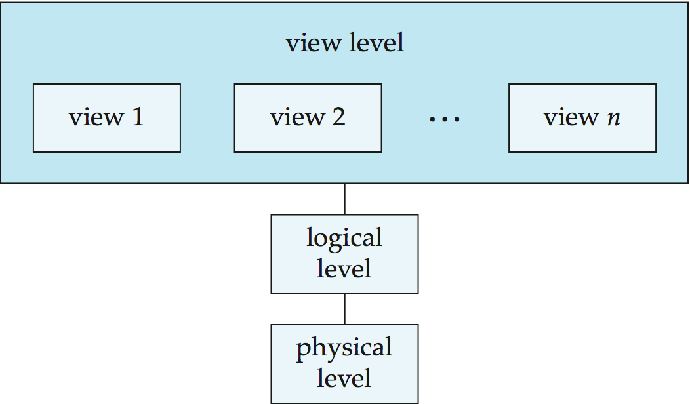

- Logical Schema – the overall logical structure of the database
  - Example: The database consists of information about a set of customers and accounts in a bank and the relationship between them
    - Analogous to type information of a variable in a program
- Physical schema– the overall physical structure of the database
- Instance – the actual content of the database at a particular point in time
  - Analogous to the value of a variable
- Physical Data Independence – the ability to modify the physical schema without changing the logical schema
  - Applications depend on the logical schema
  - In general, the interfaces between the various levels and components should be well defined so that changes in some parts do not seriously influence others.

Data Models:

Entity Relation Model

Entity-Relationship (ER) Model is based on the notion of real-world entities and relationships among them. While formulating real-world scenario into the database model, the ER Model creates entity set, relationship set, general attributes, and constraints.

ER Model is best used for the conceptual design of a database.

ER Model is based on:
- Entities and their attributes.
- Relationships among entities.

Entity
An entity in an ER Model is a real-world entity having properties called attributes.
Every attribute is defined by its set of values called domain.

For example, in a school database, a student is considered as an entity. Student has various attributes like name, age, class, etc.

Relationship
The logical association among entities is called relationship. Relationships are mapped with entities in various ways. Mapping cardinalities define the number of association between two entities.

Mapping cardinalities:
o one to one
o one to many
o many to one
o many to many
Relational Model

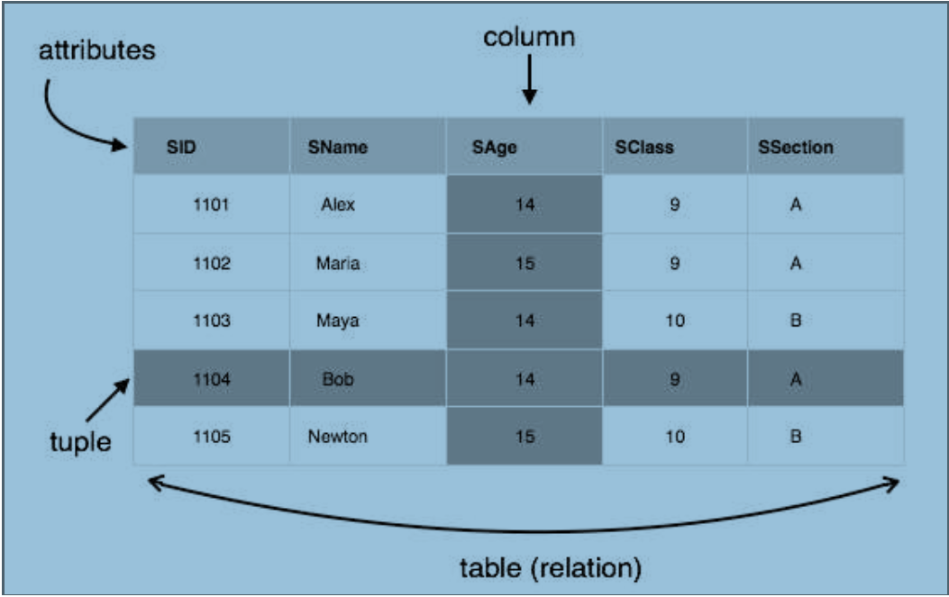
The most popular data model in DBMS is the Relational Model. It is more Scientific a model than others. This model is based on first-order predicate logic and defines a table as an n-ary relation

The main highlights of this model are:
- Data is stored in tables called relations.
- Relations can be normalized.
- In normalized relations, values saved are atomic values.
- Each row in a relation contains a unique value

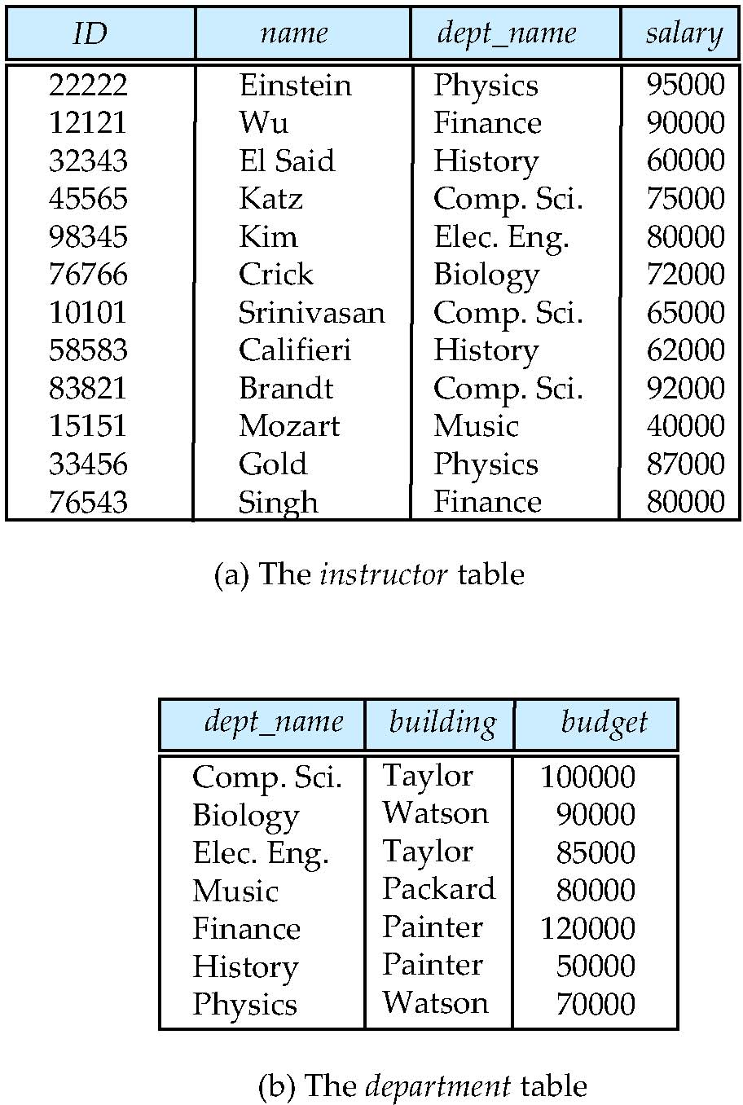
Example:

Data Definition Language

- Specification notation for defining the database schema
- Example: create table instructor (
ID char(5),
name varchar(20),
dept_name varchar(20),
salary numeric(8,2))
- DDL compiler generates a set of table templates stored in a data dictionary
- Data dictionary contains metadata (i.e., data about data)
  - Database schema
  - Integrity constraints
    - Primary key (ID uniquely identifies instructors)
  - Authorization
    - Who can access what

Data Manipulation Language
- Language for accessing and manipulating the data organized by the appropriate data model
  - DML also known as query language
- Two classes of languages
  - Pure – used for proving properties about computational power and for optimization
    - Relational Algebra
    - Tuple relational calculus
    - Domain relational calculus
  - Commercial – used in commercial systems
    - SQL is the most widely used commercial language

Structure Query Language

- The most widely used commercial language
- SQL is NOT a Turing machine equivalent language
- SQL is NOT a Turing machine equivalent language
- To be able to compute complex functions SQL is usually embedded in some higher-level language
- Application programs generally access databases through one of
  - Language extensions to allow embedded SQL
  - Application program interface (e.g., ODBC/JDBC) which allow SQL queries to be sent to a database

Storage Management

- Storage manager is a program module that provides the interface between the low-level data stored in the database and the application programs and queries submitted to the system.
- The storage manager is responsible to the following tasks:
  - Interaction with the OS file manager
  - Efficient storing, retrieving and updating of data

- Issues:
  - Storage access
  - File organization
  - Indexing and hashing

Query Processing

1. Parsing and translation
2. Optimization
3. Evaluation

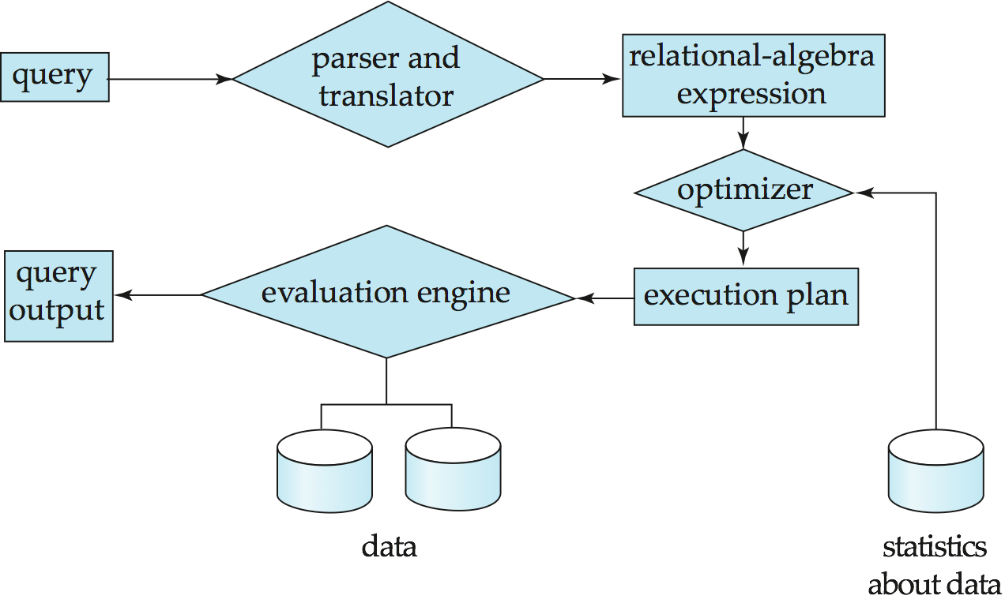

Transaction Management

- A transaction is a collection of operations that performs a single logical function in a database application
- Transaction-management component ensures that the database remains in a consistent (correct) state despite system failures (e.g., power failures and operating system crashes) and transaction failures.
- Concurrency-control manager controls the interaction among the concurrent transactions, to ensure the consistency of the database.

Relational Model
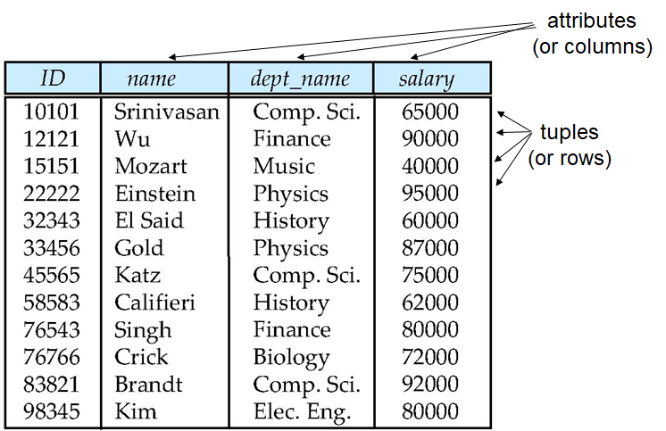

Relation schema and Instance

- A₁, A₂, …, A_{n} are attributes
- R = (A₁, A₂, …, A_{n} ) is a relation schema
  - Example:
  - instructor = (ID, name, dept_name, salary)
- Formally, given sets D₁, D₂, …. D_{n} a relation r is a subset of
D₁ x D₂ x … x D_{n}
Thus, a relation is a set of n-tuples (a₁, a₂, …, a_{n}) where each a_{i} ∈ D_{i}

- The current values (relation instance) of a relation are specified by a table
- An element t of r is a tuple, represented by a row in a table

Keys

- Let K ⊆ R
- K is a superkey of R if values for K are sufficient to identify a unique tuple of each possible relation r(R)
- Example: {ID} and {ID,name} are both superkeys of instructor.
- Superkey K is a candidate key if K is minimal
Example: {ID} is a candidate key for Instructor
- One of the candidate keys is selected to be the primary key.
- which one?
- Foreign key constraint: Value in one relation must appear in another
- Referencing relation
- Referenced relation
- Example – dept_name in instructor is a foreign key from instructor referencing department

Relational Query Language:

- Procedural vs .non-procedural, or declarative
- “Pure” languages:
  - Relational algebra
  - Tuple relational calculus
  - Domain relational calculus
- The above 3 pure languages are equivalent in computing power
- We will concentrate in this chapter on relational algebra
  - Not turning-machine equivalent
  - consists of 6 basic operations

Select Operation – selection of rows (tuples)
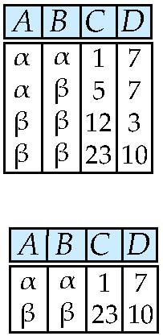

- Relation r

- σ_{A=B ^ D > 5} (r)

Project Operation – selection of columns (Attributes)
- Relation r:
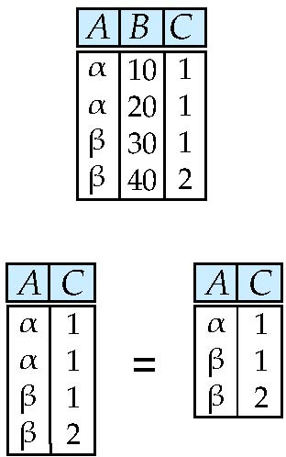

- ∏_{A,C} (r)

Union of two relations
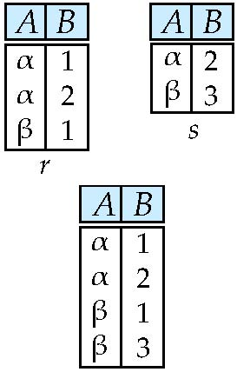
- Relations r, s:

- r ∪ s:

Set Difference of two relation
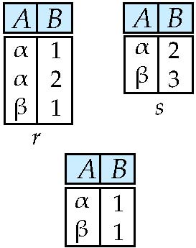

- Relations r, s:

- r – s:

Set Intersection of two relations
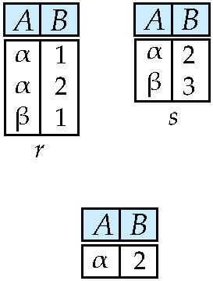
- Relation r, s:

- r ∩ s
Note: r ∩ s = r – (r – s)

joining two relations -- Cartesian-product
- r x s:

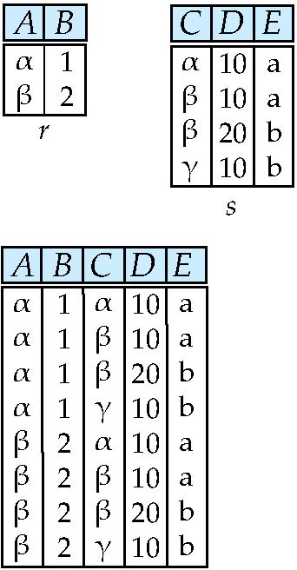
- Relations r, s:

Natural Join
∏ _{A, r.B, C, r.D, E} (σ _{r.B = s.B ˄ r.D = s.D} (r x s)))

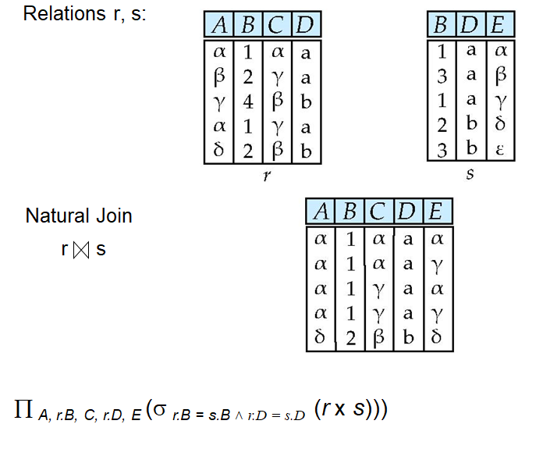

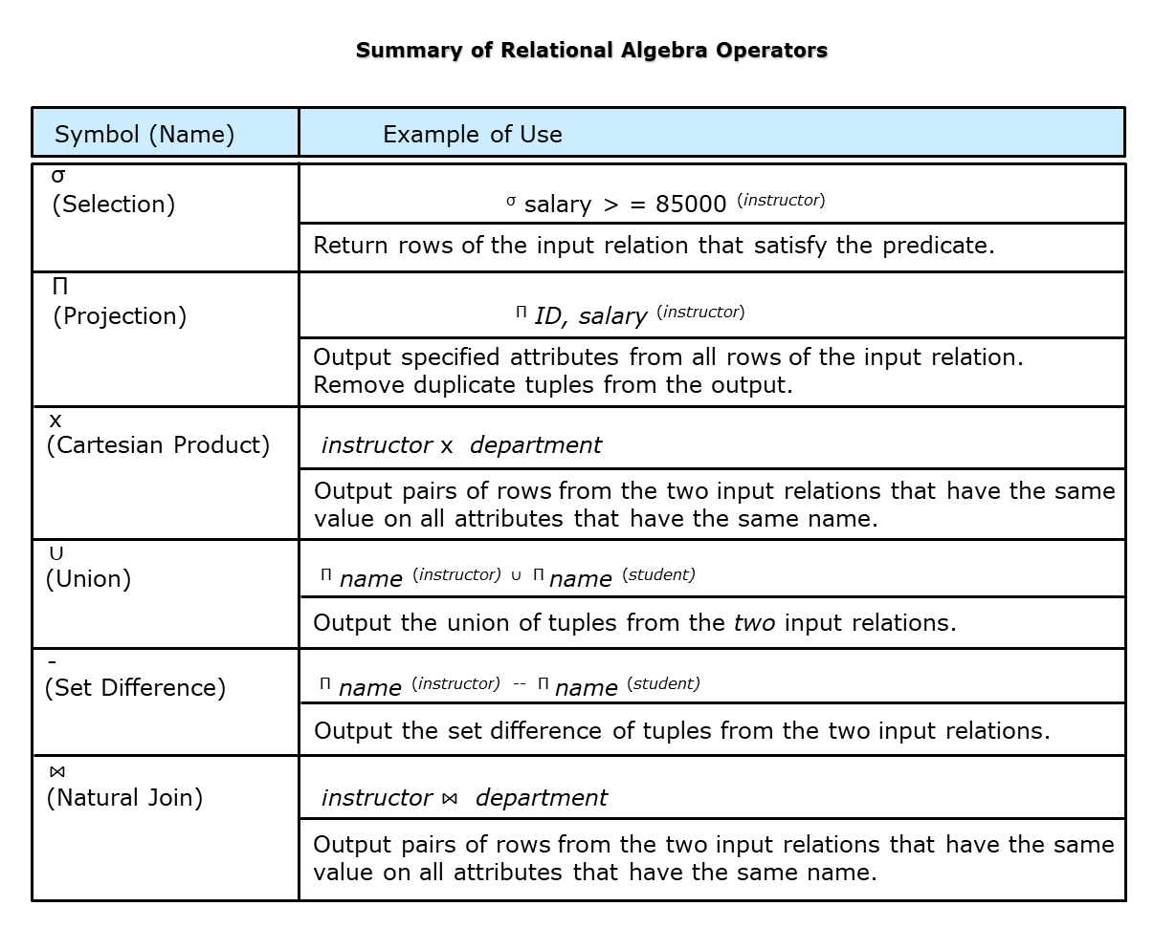

Introduction to SQL (Structured Query Language)

Basic Data types in SQL:

- char(n). Fixed length character string, with user-specified length n.
- varchar(n). Variable length character strings, with user-specified maximum length n.
- int. Integer (a finite subset of the integers that is machine-dependent).
- Small int. Small integer (a machine-dependent subset of the integer domain type).
- numeric(p,d). Fixed point number, with user-specified precision of p digits, with d digits to the right of decimal point. (ex., numeric(3,1), allows 44.5 to be stores exactly, but not 444.5 or 0.32)
- real, double precision. Floating point and double-precision floating point numbers, with machine-dependent precision.
- float(n). Floating point number, with user-specified precision of at least n digits.

CREATE TABLE:

An SQL relation is defined using the create table command:
create table r (A₁ D₁, A₂ D₂, ..., A_{n} D_{n},
(integrity-constraint₁),
...,
(integrity-constraint_{k}))
r is the name of the relation
each A_{i} is an attribute name in the schema of relation r
D_{i} is the data type of values in the domain of attribute A_{i}
Example:
create table instructor (
ID char(5),
name varchar(20),
dept_name varchar(20),
salary numeric(8,2));

Integrity constraint in create table

- not null
- primary key (A₁, ..., A_{n} )
- foreign key (A_{m}, ..., A_{n} ) references r

- Example:
- create table instructor (
ID char(5),
name varchar(20) not null,
dept_name varchar(20),
salary numeric(8,2),
primary key (ID),
foreign key (dept_name) references department);

Updates to table:
- Insert
  - insert into instructor values (‘10211’, ’Smith’, ’Biology’, 66000);
- Delete
    - Remove all tuples from the student relation
    - delete from student
- Drop Table
  - drop table r
- Alter
  - alter table r add A D
      - Where A is the name of the attribute to be added to relation r and D is the domain of A.
    - All exiting tuples in the relation are assigned null as the value for the new attribute.
  - alter table r drop A
    - where A is the name of an attribute of relation r
    - Dropping of attributes not supported by many databases.
Select Query

- The select clause lists the attributes desired in the result of a query
  - corresponds to the projection operation of the relational algebra
- Example: find the names of all instructors:
select name
from instructor
- NOTE: SQL names are case insensitive (i.e., you may use upper- or lower-case letters.)
  - E.g., Name ≡ NAME ≡ name
  - Some people use upper case wherever we use bold font.
- SQL allows duplicates in relations as well as in query results.
- To force the elimination of duplicates, insert the keyword distinct after select.
- Find the department names of all instructors, and remove duplicates
    - select distinct dept from instructor
- The keyword all specifies that duplicates should not be removed.
    - select all dept_name from instructor
- An asterisk in the select clause denotes “all attributes”
      - select * from instructor
- An attribute can be a literal with no from clause
      - select ‘437’
  - Results is a table with one column and a single row with value “437”
  - Can give the column a name using:
    - select ‘437’ as FOO
- An attribute can be a literal with from clause
      - select ‘A’ from instructor
  - Result is a table with one column and N rows (number of tuples in the instructors table), each row with value “A”

- The select clause can contain arithmetic expressions involving the operation, +, –, *, and /, and operating on constants or attributes of tuples.
  - The query:
  - select ID, name, salary from instructor
would return a relation that is the same as the instructor relation, except that the value of the attribute salary is divided by 12.
- Can rename “salary/12” using the as clause:
  - select ID, name, salary/12 as monthly_salary

The where clause
- The where clause specifies conditions that the result must satisfy
  - Corresponds to the selection predicate of the relational algebra.
- To find all instructors in Comp. Sci. dept
    - select name
from instructor
where dept_name = ‘Comp. Sci.'
- Comparison results can be combined using the logical connectives and, or, and not
  - To find all instructors in Comp. Sci. dept with salary > 80000
    - select name
from instructor
where dept_name = ‘Comp. Sci.' and salary > 80000
- Comparisons can be applied to results of arithmetic expressions

The From clause

- The from clause lists the relations involved in the query
  - Corresponds to the Cartesian product operation of the relational algebra.
- Find the Cartesian product instructor X teaches
      - select * from instructor, teaches
  - generates every possible instructor – teaches pair, with all attributes from both relations.
  - For common attributes (e.g., ID), the attributes in the resulting table are renamed using the relation name (e.g., instructor.ID)
- Cartesian product not very useful directly, but useful combined with where-clause condition (selection operation in relational algebra).

Cartesian Product Example:

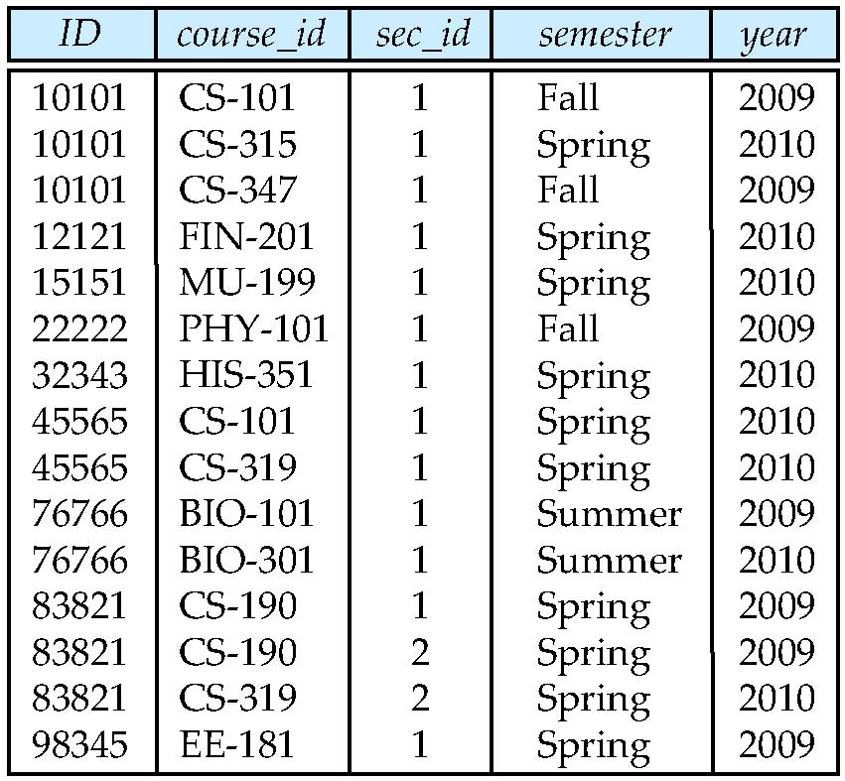
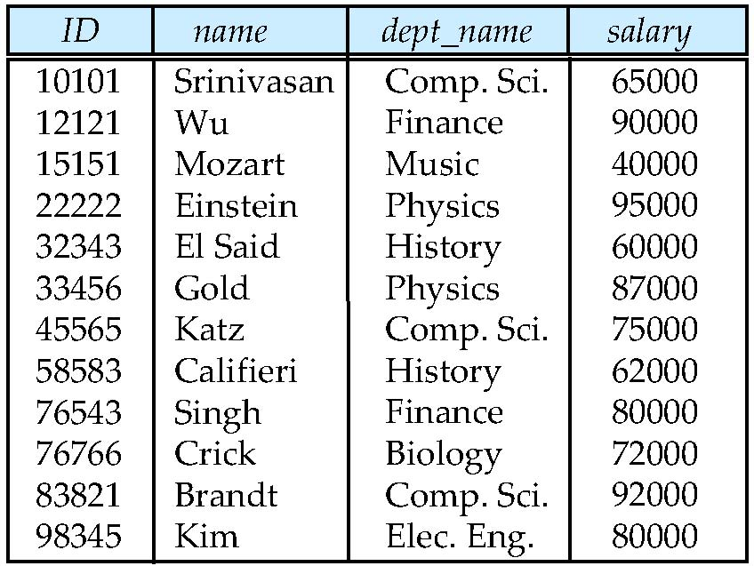
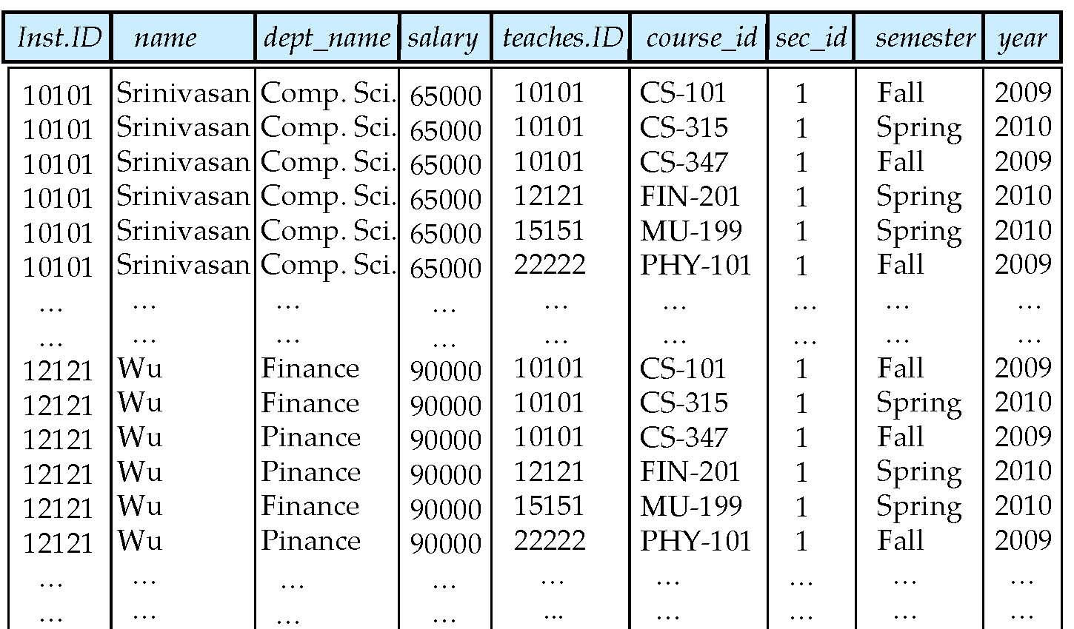

Examples:

- Find the names of all instructors who have taught some course and the course_id
  - select name, course_id
from instructor , teaches
where instructor.ID = teaches.ID
- Find the names of all instructors in the Art department who have taught some course and the course_id
  - select name, course_id
from instructor , teaches
where instructor.ID = teaches.ID and instructor. dept_name = ‘Art’

Rename operation:

- The SQL allows renaming relations and attributes using the as clause:
    - old-name as new-name
- Find the names of all instructors who have a higher salary than
some instructor in ‘Comp. Sci’.
  - select distinct T.name
from instructor as T, instructor as S
where T.salary > S.salary and S.dept_name = ‘Comp. Sci.’
- Keyword as is optional and may be omitted
instructor as T ≡ instructor T

String Operations

- SQL includes a string-matching operator for comparisons on character strings. The operator like uses patterns that are described using two special characters:
  - percent ( % ). The % character matches any substring.
  - underscore ( _ ). The _ character matches any character.
- Find the names of all instructors whose name includes the substring “dar”.
    - select name
from instructor
where name like '%dar%'
- Match the string “100%”
      - like ‘100 \%' escape '\'
- in that above we use backslash (\) as the escape character.

- Patterns are case sensitive.
- Pattern matching examples:
  - ‘Intro%’ matches any string beginning with “Intro”.
  - ‘%Comp%’ matches any string containing “Comp” as a substring.
  - ‘_ _ _’ matches any string of exactly three characters.
  - ‘_ _ _ %’ matches any string of at least three characters.
- SQL supports a variety of string operations such as
  - concatenation (using “||”)
  - converting from upper to lower case (and vice versa)
  - finding string length, extracting substrings, etc.

Between Clause

- SQL includes a between comparison operator
- Example: Find the names of all instructors with salary between $90,000 and $100,000 (that is, ³ $90,000 and £ $100,000)
  - select name
from instructor
where salary between 90000 and 100000
- Tuple comparison
  - select name, course_id
from instructor, teaches
where (instructor.ID, dept_name) = (teaches.ID, ’Biology’);

Duplicates:

- In relations with duplicates, SQL can define how many copies of tuples appear in the result.
- Multi set versions of some of the relational algebra operators – given multi set relations r₁ and r₂:
- σ_{θ} (r₁): If there are c₁ copies of tuple t₁ in r₁, and t₁ satisfies selections σ_{θ,}, then
there are c₁ copies of t₁ in σ_{θ} (r₁).

- Π_{A} (r ): For each copy of tuple t₁ in r₁, there is a copy of tuple Π_{A} (t₁) in Π_{A} (r₁)
where Π_{A} (t₁) denotes the projection of the single tuple t₁.

- r₁ x r₂: If there are c₁ copies of tuple t₁ in r₁ and c₂ copies of tuple t₂ in r₂, there are
c₁ x c₂ copies of the tuple t₁. t₂ in r₁ x r₂

Set Operations

- Find courses that ran in Fall 2009 or in Spring 2010
(select course_id from section where sem = ‘Fall’ and year = 2009)
union
(select course_id from section where sem = ‘Spring’ and year = 2010)

- Find courses that ran in Fall 2009 and in Spring 2010
(select course_id from section where sem = ‘Fall’ and year = 2009)
intersect
(select course_id from section where sem = ‘Spring’ and year = 2010)

- Find courses that ran in Fall 2009 but not in Spring 2010
(select course_id from section where sem = ‘Fall’ and year = 2009)
except
(select course_id from section where sem = ‘Spring’ and year = 2010)

- Find the salaries of all instructors that are less than the largest salary.
  - select distinct T.salary
from instructor as T, instructor as S
where T.salary < S.salary
- Find all the salaries of all instructors
  - select distinct salary
from instructor
- Find the largest salary of all instructors.
    - (select “second query” )
except
(select “first query”)

- Set operations union, intersect, and except
  - Each of the above operations automatically eliminates duplicates
- To retain all duplicates use the corresponding multiset versions union all, intersect all and except all.
- Suppose a tuple occurs m times in r and n times in s, then, it occurs:
  - m + n times in r union all s
  - min(m,n) times in r intersect all s
  - max(0, m – n) times in r except all s

NULL Values

- It is possible for tuples to have a null value, denoted by null, for some of their attributes
- null signifies an unknown value or that a value does not exist.
- The result of any arithmetic expression involving null is null
  - Example: 5 + null returns null
- The predicate is null can be used to check for null values.
  - Example: Find all instructors whose salary is null.
    - select name from instructor where salary is null
- Three values – true, false, unknown
- Any comparison with null returns unknown
  - Example: 5 < null or null <> null or null = null
- Three-valued logic using the value unknown:
  - OR: (unknown or true) = true,
(unknown or false) = unknown
(unknown or unknown) = unknown
  - AND: (true and unknown) = unknown,
(false and unknown) = false,
(unknown and unknown) = unknown
  - NOT: (not unknown) = unknown
  - “P is unknown” evaluates to true if predicate P evaluates to unknown
- Result of where clause predicate is treated as false if it evaluates to unknown

Aggregate functions

- These functions operate on the multiset of values of a column of a relation, and return a value
    - avg: average value
min: minimum value
max: maximum value
sum: sum of values
count: number of values
Examples:
- Find the average salary of instructors in the Computer Science department
  - select avg (salary)
from instructor
where dept_name= ’Comp. Sci.’;
- Find the total number of instructors who teach a course in the Spring 2010 semester
  - select count (distinct ID)
from teaches
where semester = ’Spring’ and year = 2010;
- Find the number of tuples in the course relation
  - select count (*)
from course;

Group by Function

- Find the average salary of instructors in each department
  - select dept_name, avg (salary) as avg_salary
from instructor
group by dept_name;
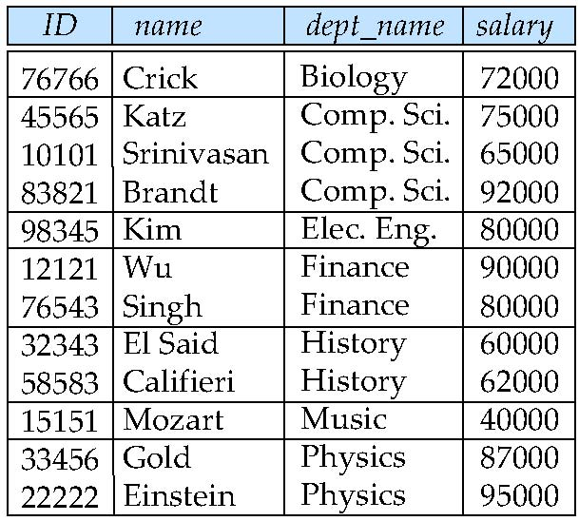
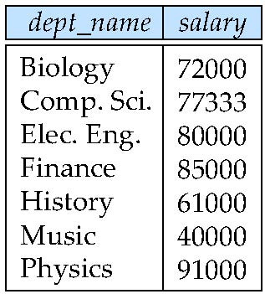

Aggregate Function: Having clause

select dept_name, avg (salary) from instructor group by dept_nam having avg (salary) > 42000;

Nested Sub queries:

- SQL provides a mechanism for the nesting of subqueries. A subquery is a select-from-where expression that is nested within another query.
- The nesting can be done in the following SQL query
select A₁, A₂, ..., A_{n}
from r₁, r₂, ..., r_{m}
where P
- as follows:
- A_{i} can be replaced be a subquery that generates a single value.
- r_{i} can be replaced by any valid subquery
- P can be replaced with an expression of the form:
- B <operation> (subquery)
- Where B is an attribute and <operation> to be defined later.

Sub queries in where clause:

- A common use of subqueries is to perform tests:
    - For set membership
    - For set comparisons
    - For set cardinality.

- Find courses offered in Fall 2009 and in Spring 2010

select distinct course_id
from section
where semester = ’Fall’ and year= 2009 and
course_id in (select course_id
from section
where semester = ’Spring’ and year= 2010);

- Find courses offered in Fall 2009 but not in Spring 2010

select distinct course_id
from section
where semester = ’Fall’ and year= 2009 and
course_id not in (select course_id
from section
where semester = ’Spring’ and year= 2010);

- Find the total number of (distinct) students who have taken course sections taught
by the instructor with ID 10101

select count (distinct ID)
from takes
where (course_id, sec_id, semester, year) in
(select course_id, sec_id, semester, year
from teaches
where teaches.ID= 10101);

Set Comparison – “some” Clause

Find names of instructors with salary greater than that of some (at least one) instructor
in the Biology department.

select distinct T.name
from instructor as T, instructor as S
where T.salary > S.salary and S.dept name = ’Biology’;

Same query using > some clause

select name
from instructor
where salary > some (select salary
from instructor
where dept name = ’Biology’);

Definition of Some clause:

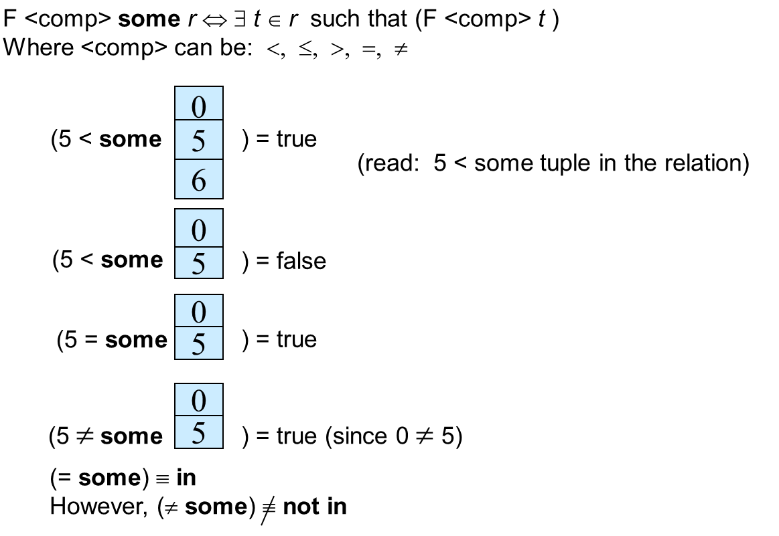

Set comparison: all clause

- Find the names of all instructors whose salary is greater than the salary of all instructors in the Biology department.

- select name from instructor where salary > all (select salary from instructor
where dept name = ’Biology’);

Definition of ‘all’ clause

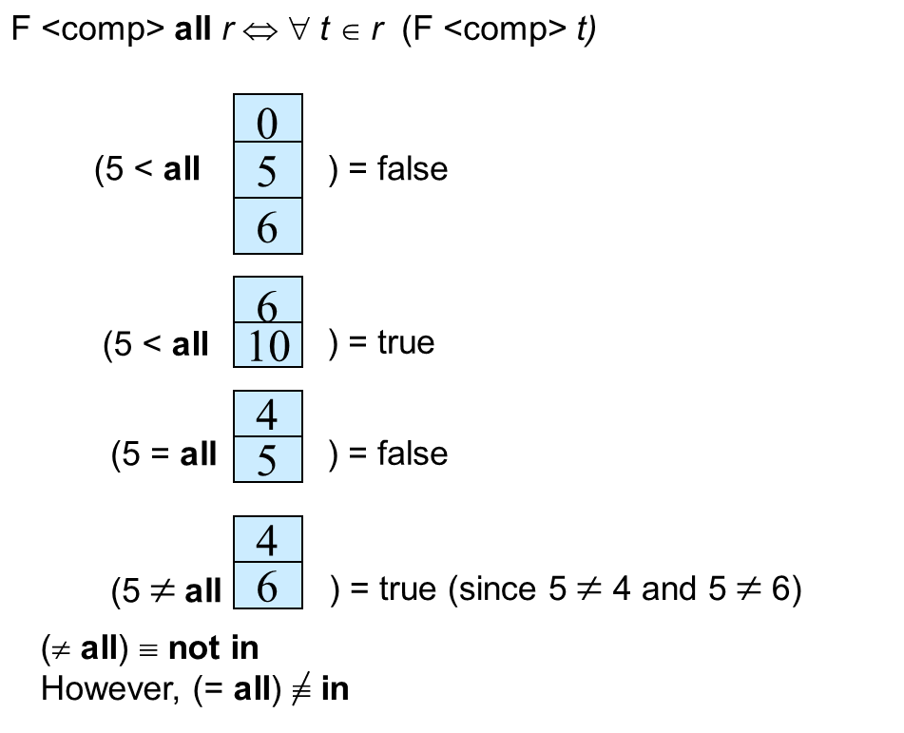

Test for Empty relation

- The exists construct returns the value true if the argument subquery is nonempty.
- exists r ⇔ r ≠ Ø
- not exists r ⇔ r = Ø

Use of Exist clause

- Yet another way of specifying the query “Find all courses taught in both the Fall 2009 semester and in the Spring 2010 semester”
  - select course_id
from section as S
where semester = ’Fall’ and year = 2009 and
exists (select *
from section as T
where semester = ’Spring’ and year= 2010
and S.course_id = T.course_id);
- Correlation name – variable S in the outer query
- Correlated subquery – the inner query
Use of ‘not exist’ clause

- Find all students who have taken all courses offered in the Biology department.

select distinct S.ID, S.name from student as S where not exists ( (select course_id
from course where dept_name = ’Biology’) except (select T.course_id from takes as T
where S.ID = T.ID));

- First nested query lists all courses offered in Biology
- Second nested query lists all courses a particular student took

Identify duplicate tuples

- The unique construct tests whether a subquery has any duplicate tuples in its result.
- The unique construct evaluates to “true” if a given subquery contains no duplicates .

- Find all courses that were offered at most once in 2009
select T.course_id
from course as T
where unique (select R.course_id
from section as R
where T.course_id= R.course_id
and R.year = 2009);

Sub queries in the form clause

- SQL allows a subquery expression to be used in the from clause

- Find the average instructors’ salaries of those departments where the average salary is greater than $42,000.”

select dept_name, avg_salary
from (select dept_name, avg (salary) as avg_salary
from instructor
group by dept_name)
where avg_salary > 42000;

- Note that we do not need to use the having clause

- Another way to write above query
select dept_name, avg_salary
from (select dept_name, avg (salary)
from instructor
group by dept_name) as dept_avg (dept_name, avg_salary)
where avg_salary > 42000;

With Clause

- The with clause provides a way of defining a temporary relation whose definition is available only to the query in which the with clause occurs.
- Find all departments with the maximum budget
with max_budget (value) as
(select max(budget)
from department)
select department.name
from department, max_budget
where department.budget = max_budget.value;

Scalar Subquery

- Scalar subquery is one which is used where a single value is expected
- List all departments along with the number of instructors in each department
  - select dept_name,
(select count(*)
from instructor
where department.dept_name = instructor.dept_name)
as num_instructors
from department;
- Runtime error if subquery returns more than one result tuple

Deletion

- Delete all instructors
    - delete from instructor
- Delete all instructors from the Finance department
delete from instructor
where dept_name= ’Finance’;
- Delete all tuples in the instructor relation for those instructors associated with a department located in the Watson building.
    - delete from instructor
where dept name in (select dept name
from department
where building = ’Watson’);
Insertion

- Add a new tuple to course
    - insert into values (’CS-437’, ’Database Systems’, ’Comp. Sci.’, 4);

or equivalently

    - insert into course (course_id, title, dept_name, credits)
values (’CS-437’, ’Database Systems’, ’Comp. Sci.’, 4);

- Add a new tuple to student with tot_creds set to null
    - insert into student
values (’3003’, ’Green’, ’Finance’, null);

- Add all instructors to the student relation with tot_creds set to 0
insert into student
select ID, name, dept_name, 0
from instructor

- The select from where statement is evaluated fully before any of its results are inserted into the relation.

- Otherwise queries like

insert into table1 select * from table1

would cause problem

Updates

- Increase salaries of instructors whose salary is over $100,000 by 3%, and all others by a 5%
  - Write two update statements:
    - update instructor
set salary = salary * 1.03
where salary > 100000;
update instructor
set salary = salary * 1.05
where salary <= 100000;
  - The order is important
  - Can be done better using the case statement (next slide)

Updates with scalar sub query

- Recompute and update tot_creds value for all students
update student S
set tot_cred = (select sum(credits)
from takes, course
where takes.course_id = course.course_id and
S.ID= takes.ID.and takes.grade <> ’F’ and
takes.grade is not null);
- Sets tot_creds to null for students who have not taken any course

Instead of sum(credits), use:
    - case
when sum(credits) is not null then sum(credits)
else 0
end
SQL Using Views:

A view is nothing more than a SQL statement that is stored in the database with an associated name. A view is actually a composition of a table in the form of a predefined SQL query.
A view can contain all rows of a table or select rows from a table. A view can be created from one or many tables which depends on the written SQL query to create a view.
Views, which are a type of virtual tables allow users to do the following −
- Structure data in a way that users or classes of users find natural or intuitive.
- Restrict access to the data in such a way that a user can see and (sometimes) modify exactly what they need and no more.
- Summarize data from various tables which can be used to generate reports.

Creating Views
Database views are created using the CREATE VIEW statement. Views can be created from a single table, multiple tables or another view.
To create a view, a user must have the appropriate system privilege according to the specific implementation.
The basic CREATE VIEW syntax is as follows −
CREATE VIEW view_name AS
SELECT column1, column2.....
FROM table_name
WHERE [condition];
You can include multiple tables in your SELECT statement in a similar way as you use them in a normal SQL SELECT query.

Example
Consider the CUSTOMERS table having the following records −
+----+----------+-----+-----------+----------+
| ID | NAME | AGE | ADDRESS | SALARY |
+----+----------+-----+-----------+----------+
| 1 | Ramesh | 32 | Ahmedabad | 2000.00 |
| 2 | Khilan | 25 | Delhi | 1500.00 |
| 3 | kaushik | 23 | Kota | 2000.00 |
| 4 | Chaitali | 25 | Mumbai | 6500.00 |
| 5 | Hardik | 27 | Bhopal | 8500.00 |
| 6 | Komal | 22 | MP | 4500.00 |
| 7 | Muffy | 24 | Indore | 10000.00 |

Following is an example to create a view from the CUSTOMERS table. This view would be used to have customer name and age from the CUSTOMERS table.
SQL > CREATE VIEW CUSTOMERS_VIEW AS
SELECT name, age
FROM CUSTOMERS;
Now, you can query CUSTOMERS_VIEW in a similar way as you query an actual table. Following is an example for the same.
SQL > SELECT * FROM CUSTOMERS_VIEW;
This would produce the following result.
+----------+-----+
| name | age |
+----------+-----+
| Ramesh | 32 |
| Khilan | 25 |
| kaushik | 23 |
| Chaitali | 25 |
| Hardik | 27 |
| Komal | 22 |
| Muffy | 24 |

The WITH CHECK OPTION
The WITH CHECK OPTION is a CREATE VIEW statement option. The purpose of the WITH CHECK OPTION is to ensure that all UPDATE and INSERTs satisfy the condition(s) in the view definition.
If they do not satisfy the condition(s), the UPDATE or INSERT returns an error.
The following code block has an example of creating same view CUSTOMERS_VIEW with the WITH CHECK OPTION.
CREATE VIEW CUSTOMERS_VIEW AS
SELECT name, age
FROM CUSTOMERS
WHERE age IS NOT NULL
WITH CHECK OPTION;
The WITH CHECK OPTION in this case should deny the entry of any NULL values in the view's AGE column, because the view is defined by data that does not have a NULL value in the AGE column.

Updating a View
A view can be updated under certain conditions which are given below −
- The SELECT clause may not contain the keyword DISTINCT.
- The SELECT clause may not contain summary functions.
- The SELECT clause may not contain set functions.
- The SELECT clause may not contain set operators.
- The SELECT clause may not contain an ORDER BY clause.
- The FROM clause may not contain multiple tables.
- The WHERE clause may not contain subqueries.
- The query may not contain GROUP BY or HAVING.
- Calculated columns may not be updated.
- All NOT NULL columns from the base table must be included in the view in order for the INSERT query to function.
So, if a view satisfies all the above-mentioned rules then you can update that view. The following code block has an example to update the age of Ramesh.
SQL > UPDATE CUSTOMERS_VIEW
SET AGE = 35
WHERE name = 'Ramesh';
This would ultimately update the base table CUSTOMERS and the same would reflect in the view itself. Now, try to query the base table and the SELECT statement would produce the following result.
+----+----------+-----+-----------+----------+
| ID | NAME | AGE | ADDRESS | SALARY |
+----+----------+-----+-----------+----------+
| 1 | Ramesh | 35 | Ahmedabad | 2000.00 |
| 2 | Khilan | 25 | Delhi | 1500.00 |
| 3 | kaushik | 23 | Kota | 2000.00 |
| 4 | Chaitali | 25 | Mumbai | 6500.00 |
| 5 | Hardik | 27 | Bhopal | 8500.00 |
| 6 | Komal | 22 | MP | 4500.00 |
| 7 | Muffy | 24 | Indore | 10000.00 |

Inserting Rows into a View
Rows of data can be inserted into a view. The same rules that apply to the UPDATE command also apply to the INSERT command.
Here, we cannot insert rows in the CUSTOMERS_VIEW because we have not included all the NOT NULL columns in this view, otherwise you can insert rows in a view in a similar way as you insert them in a table.

Deleting Rows into a View
Rows of data can be deleted from a view. The same rules that apply to the UPDATE and INSERT commands apply to the DELETE command.
Following is an example to delete a record having AGE = 22.
SQL > DELETE FROM CUSTOMERS_VIEW
WHERE age = 22;
This would ultimately delete a row from the base table CUSTOMERS and the same would reflect in the view itself. Now, try to query the base table and the SELECT statement would produce the following result.
+----+----------+-----+-----------+----------+
| ID | NAME | AGE | ADDRESS | SALARY |
+----+----------+-----+-----------+----------+
| 1 | Ramesh | 35 | Ahmedabad | 2000.00 |
| 2 | Khilan | 25 | Delhi | 1500.00 |
| 3 | kaushik | 23 | Kota | 2000.00 |
| 4 | Chaitali | 25 | Mumbai | 6500.00 |
| 5 | Hardik | 27 | Bhopal | 8500.00 |
| 7 | Muffy | 24 | Indore | 10000.00 |
+----+----------+-----+-----------+----------+

Dropping Views
Obviously, where you have a view, you need a way to drop the view if it is no longer needed. The syntax is very simple and is given below −
DROP VIEW view_name;
Following is an example to drop the CUSTOMERS_VIEW from the CUSTOMERS table.
DROP VIEW CUSTOMERS_VIEW;

SQL Transaction

A transaction is a unit of work that is performed against a database. Transactions are units or sequences of work accomplished in a logical order, whether in a manual fashion by a user or automatically by some sort of a database program.
A transaction is the propagation of one or more changes to the database. For example, if you are creating a record or updating a record or deleting a record from the table, then you are performing a transaction on that table. It is important to control these transactions to ensure the data integrity and to handle database errors.
Practically, you will club many SQL queries into a group and you will execute all of them together as a part of a transaction.

Properties of Transactions
Transactions have the following four standard properties, usually referred to by the acronym ACID.
- Atomicity − ensures that all operations within the work unit are completed successfully. Otherwise, the transaction is aborted at the point of failure and all the previous operations are rolled back to their former state.
- Consistency − ensures that the database properly changes states upon a successfully committed transaction.
- Isolation − enables transactions to operate independently of and transparent to each other.
- Durability − ensures that the result or effect of a committed transaction persists in case of a system failure.

Transaction Control
The following commands are used to control transactions.
- COMMIT − to save the changes.
- ROLLBACK − to roll back the changes.
- SAVEPOINT − creates points within the groups of transactions in which to ROLLBACK.
- SET TRANSACTION − Places a name on a transaction.

Transactional Control Commands
Transactional control commands are only used with the DML Commands such as - INSERT, UPDATE and DELETE only. They cannot be used while creating tables or dropping them because these operations are automatically committed in the database.

The COMMIT Command
The COMMIT command is the transactional command used to save changes invoked by a transaction to the database.
The COMMIT command is the transactional command used to save changes invoked by a transaction to the database. The COMMIT command saves all the transactions to the database since the last COMMIT or ROLLBACK command.
The syntax for the COMMIT command is as follows.
COMMIT;
Example
Consider the CUSTOMERS table having the following records −
+----+----------+-----+-----------+----------+
| ID | NAME | AGE | ADDRESS | SALARY |
+----+----------+-----+-----------+----------+
| 1 | Ramesh | 32 | Ahmedabad | 2000.00 |
| 2 | Khilan | 25 | Delhi | 1500.00 |
| 3 | kaushik | 23 | Kota | 2000.00 |
| 4 | Chaitali | 25 | Mumbai | 6500.00 |
| 5 | Hardik | 27 | Bhopal | 8500.00 |
| 6 | Komal | 22 | MP | 4500.00 |
| 7 | Muffy | 24 | Indore | 10000.00 |
+----+----------+-----+-----------+----------+
Following is an example which would delete those records from the table which have age = 25 and then COMMIT the changes in the database.
SQL> DELETE FROM CUSTOMERS
WHERE AGE = 25;
SQL> COMMIT;

Thus, two rows from the table would be deleted and the SELECT statement would produce the following result.
+----+----------+-----+-----------+----------+
| ID | NAME | AGE | ADDRESS | SALARY |
+----+----------+-----+-----------+----------+
| 1 | Ramesh | 32 | Ahmedabad | 2000.00 |
| 3 | kaushik | 23 | Kota | 2000.00 |
| 5 | Hardik | 27 | Bhopal | 8500.00 |
| 6 | Komal | 22 | MP | 4500.00 |
| 7 | Muffy | 24 | Indore | 10000.00 |
+----+----------+-----+-----------+----------+

The ROLLBACK Command
The ROLLBACK command is the transactional command used to undo transactions that have not already been saved to the database. This command can only be used to undo transactions since the last COMMIT or ROLLBACK command was issued.
The syntax for a ROLLBACK command is as follows −
ROLLBACK;
Example
Consider the CUSTOMERS table having the following records −
+----+----------+-----+-----------+----------+
| ID | NAME | AGE | ADDRESS | SALARY |
+----+----------+-----+-----------+----------+
| 1 | Ramesh | 32 | Ahmedabad | 2000.00 |
| 2 | Khilan | 25 | Delhi | 1500.00 |
| 3 | kaushik | 23 | Kota | 2000.00 |
| 4 | Chaitali | 25 | Mumbai | 6500.00 |
| 5 | Hardik | 27 | Bhopal | 8500.00 |
| 6 | Komal | 22 | MP | 4500.00 |
| 7 | Muffy | 24 | Indore | 10000.00 |
+----+----------+-----+-----------+----------+
Following is an example, which would delete those records from the table which have the age = 25 and then ROLLBACK the changes in the database.
SQL> DELETE FROM CUSTOMERS
WHERE AGE = 25;
SQL> ROLLBACK;
Thus, the delete operation would not impact the table and the SELECT statement would produce the following result.
+----+----------+-----+-----------+----------+
| ID | NAME | AGE | ADDRESS | SALARY |
+----+----------+-----+-----------+----------+
| 1 | Ramesh | 32 | Ahmedabad | 2000.00 |
| 2 | Khilan | 25 | Delhi | 1500.00 |
| 3 | kaushik | 23 | Kota | 2000.00 |
| 4 | Chaitali | 25 | Mumbai | 6500.00 |
| 5 | Hardik | 27 | Bhopal | 8500.00 |
| 6 | Komal | 22 | MP | 4500.00 |
| 7 | Muffy | 24 | Indore | 10000.00 |
+----+----------+-----+-----------+----------+

The SAVEPOINT Command
A SAVEPOINT is a point in a transaction when you can roll the transaction back to a certain point without rolling back the entire transaction.
The syntax for a SAVEPOINT command is as shown below.
SAVEPOINT SAVEPOINT_NAME;
This command serves only in the creation of a SAVEPOINT among all the transactional statements. The ROLLBACK command is used to undo a group of transactions.
The syntax for rolling back to a SAVEPOINT is as shown below.
ROLLBACK TO SAVEPOINT_NAME;
Following is an example where you plan to delete the three different records from the CUSTOMERS table. You want to create a SAVEPOINT before each delete, so that you can ROLLBACK to any SAVEPOINT at any time to return the appropriate data to its original state.
Example
Consider the CUSTOMERS table having the following records.
+----+----------+-----+-----------+----------+
| ID | NAME | AGE | ADDRESS | SALARY |
+----+----------+-----+-----------+----------+
| 1 | Ramesh | 32 | Ahmedabad | 2000.00 |
| 2 | Khilan | 25 | Delhi | 1500.00 |
| 3 | kaushik | 23 | Kota | 2000.00 |
| 4 | Chaitali | 25 | Mumbai | 6500.00 |
| 5 | Hardik | 27 | Bhopal | 8500.00 |
| 6 | Komal | 22 | MP | 4500.00 |
| 7 | Muffy | 24 | Indore | 10000.00 |
+----+----------+-----+-----------+----------+
The following code block contains the series of operations.
SQL> SAVEPOINT SP1;
Savepoint created.
SQL> DELETE FROM CUSTOMERS WHERE ID=1;
1 row deleted.
SQL> SAVEPOINT SP2;
Savepoint created.
SQL> DELETE FROM CUSTOMERS WHERE ID=2;
1 row deleted.
SQL> SAVEPOINT SP3;
Savepoint created.
SQL> DELETE FROM CUSTOMERS WHERE ID=3;
1 row deleted.
Now that the three deletions have taken place, let us assume that you have changed your mind and decided to ROLLBACK to the SAVEPOINT that you identified as SP2. Because SP2 was created after the first deletion, the last two deletions are undone −
SQL> ROLLBACK TO SP2;
Rollback complete.
Notice that only the first deletion took place since you rolled back to SP2.
SQL> SELECT * FROM CUSTOMERS;
+----+----------+-----+-----------+----------+
| ID | NAME | AGE | ADDRESS | SALARY |
+----+----------+-----+-----------+----------+
| 2 | Khilan | 25 | Delhi | 1500.00 |
| 3 | kaushik | 23 | Kota | 2000.00 |
| 4 | Chaitali | 25 | Mumbai | 6500.00 |
| 5 | Hardik | 27 | Bhopal | 8500.00 |
| 6 | Komal | 22 | MP | 4500.00 |
| 7 | Muffy | 24 | Indore | 10000.00 |
+----+----------+-----+-----------+----------+
6 rows selected.

The RELEASE SAVEPOINT Command
The RELEASE SAVEPOINT command is used to remove a SAVEPOINT that you have created.
The syntax for a RELEASE SAVEPOINT command is as follows.
RELEASE SAVEPOINT SAVEPOINT_NAME;
Once a SAVEPOINT has been released, you can no longer use the ROLLBACK command to undo transactions performed since the last SAVEPOINT.

The SET TRANSACTION Command
The SET TRANSACTION command can be used to initiate a database transaction. This command is used to specify characteristics for the transaction that follows. For example, you can specify a transaction to be read only or read write.
The syntax for a SET TRANSACTION command is as follows.
SET TRANSACTION [ READ WRITE | READ ONLY ];

DATA BASE NORMALIZATION TECHNIQUES

Functional Dependency
Functional dependency (FD) is a set of constraints between two attributes in a relation. Functional dependency says that if two tuples have same values for attributes A1, A2,..., An, then those two tuples must have to have same values for attributes B1, B2, ..., Bn.
Functional dependency is represented by an arrow sign (→) that is, X→Y, where X functionally determines Y. The left-hand side attributes determine the values of attributes on the right-hand side.

Armstrong's Axioms
If F is a set of functional dependencies then the closure of F, denoted as F⁺, is the set of all functional dependencies logically implied by F. Armstrong's Axioms are a set of rules, that when applied repeatedly, generates a closure of functional dependencies.
- Reflexive rule − If alpha is a set of attributes and beta is_subset_of alpha, then alpha holds beta.
- Augmentation rule − If a → b holds and y is attribute set, then ay → by also holds. That is adding attributes in dependencies, does not change the basic dependencies.
- Transitivity rule − Same as transitive rule in algebra, if a → b holds and b → c holds, then a → c also holds. a → b is called as a functionally that determines b.

Trivial Functional Dependency
- Trivial − If a functional dependency (FD) X → Y holds, where Y is a subset of X, then it is called a trivial FD. Trivial FDs always hold.
- Non-trivial − If an FD X → Y holds, where Y is not a subset of X, then it is called a non-trivial FD.
- Completely non-trivial − If an FD X → Y holds, where x intersect Y = Φ, it is said to be a completely non-trivial FD.

Normalization
If a database design is not perfect, it may contain anomalies, which are like a bad dream for any database administrator. Managing a database with anomalies is next to impossible.
- Update anomalies − If data items are scattered and are not linked to each other properly, then it could lead to strange situations. For example, when we try to update one data item having its copies scattered over several places, a few instances get updated properly while a few others are left with old values. Such instances leave the database in an inconsistent state.
- Deletion anomalies − We tried to delete a record, but parts of it was left undeleted because of unawareness, the data is also saved somewhere else.
- Insert anomalies − We tried to insert data in a record that does not exist at all.
Normalization is a method to remove all these anomalies and bring the database to a consistent state.

First Normal Form
First Normal Form is defined in the definition of relations (tables) itself. This rule defines that all the attributes in a relation must have atomic domains. The values in an atomic domain are indivisible units.
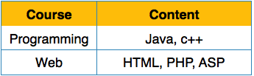
We re-arrange the relation (table) as below, to convert it to First Normal Form.
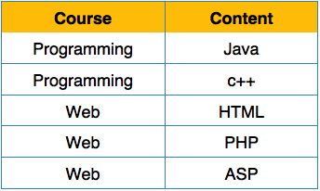
Each attribute must contain only a single value from its pre-defined domain.

Second Normal Form
Before we learn about the second normal form, we need to understand the following −
- Prime attribute − An attribute, which is a part of the prime-key, is known as a prime attribute.
- Non-prime attribute − An attribute, which is not a part of the prime-key, is said to be a non-prime attribute.
If we follow second normal form, then every non-prime attribute should be fully functionally dependent on prime key attribute. That is, if X → A holds, then there should not be any proper subset Y of X, for which Y → A also holds true.
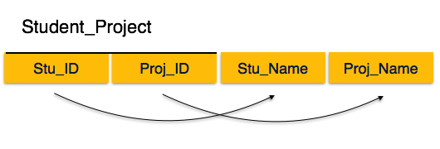
We see here in Student_Project relation that the prime key attributes are Stu_ID and Proj_ID. According to the rule, non-key attributes, i.e. Stu_Name and Proj_Name must be dependent upon both and not on any of the prime key attribute individually. But we find that Stu_Name can be identified by Stu_ID and Proj_Name can be identified by Proj_ID independently. This is called partial dependency, which is not allowed in Second Normal Form.
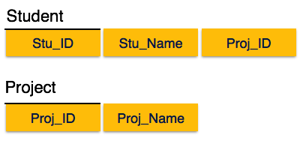
We broke the relation in two as depicted in the above picture. So there exists no partial dependency.

Third Normal Form
For a relation to be in Third Normal Form, it must be in Second Normal form and the following must satisfy −
- No non-prime attribute is transitively dependent on prime key attribute.
- For any non-trivial functional dependency, X → A, then either −
  - X is a superkey or,
  - A is prime attribute.
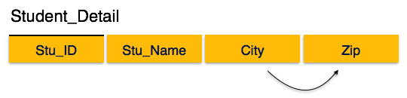
We find that in the above Student_detail relation, Stu_ID is the key and only prime key attribute. We find that City can be identified by Stu_ID as well as Zip itself. Neither Zip is a superkey nor is City a prime attribute. Additionally, Stu_ID → Zip → City, so there exists transitive dependency.
To bring this relation into third normal form, we break the relation into two relations as follows −
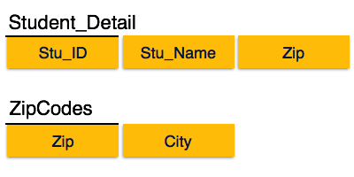

Boyce-Codd Normal Form
Boyce-Codd Normal Form (BCNF) is an extension of Third Normal Form on strict terms. BCNF states that −
- For any non-trivial functional dependency, X → A, X must be a super-key.
In the above image, Stu_ID is the super-key in the relation Student_Detail and Zip is the super-key in the relation ZipCodes. So,
Stu_ID → Stu_Name, Zip
and
Zip → City
Which confirms that both the relations are in BCNF.

EMBEDDED SQL

Embedded and dynamic SQL define how SQL statements can be embedded within general-purpose programming languages, such as C, C++, and Java.

Embedded SQL provides a means by which a program can interact with a database server. However, under embedded SQL, the SQL statements are identified at compile time using a pre-processor. The pre-processor submits the SQL statements to the database system for precompilation and optimization; then it replaces the SQL statements in the application program with appropriate code and function calls before invoking the programming-language compiler.

The SQL standard defines embedding of SQL in a variety of programming languages, such as C, C++, Cobol, Pascal, Java, PL/I, and Fortran. A language in which SQL queries are embedded is referred to as a host language, and the SQL structures permitted in the host language constitute embedded SQL. Programs written in the host language can use the embedded SQL syntax to access and update data stored in a database. An embedded SQL program must be processed by a special pre-processor prior to compilation. The pre-processor replaces embedded SQL requests with host-language declarations and procedure calls that allow runtime execution of the database accesses. Then, the resulting program is compiled by the host-language compiler. This is the main distinction between embedded SQL and JDBC or ODBC.

In JDBC, SQL statements are interpreted at runtime (even if they are prepared first using the prepared statement feature). When embedded SQL is used, some SQL-related errors (including data-type errors) may be caught at compile time.

To identify embedded SQL requests to the pre-processor, we use the EXEC SQL
statement; it has the form:

EXEC SQL <embedded SQL statement >;

The exact syntax for embedded SQL requests depends on the language in which SQL is embedded. In some languages, such as Cobol, the semicolon is replaced with END-EXEC.

We place the statement SQL INCLUDE SQLCA in the program to identify the place where the pre-processor should insert the special variables used for communication between the program and the database system.
Before executing any SQL statements, the program must first connect to the database. This is done using:

EXEC SQL connect to server user user-name using password;

Here, server identifies the server to which a connection is to be established. Variables of the host language can be used within embedded SQL statements, but they must be preceded by a colon (:) to distinguish them from SQL variables. Variables used as above must be declared within a DECLARE section, as illustrated below. The syntax for declaring the variables, however, follows the usual host anguage syntax.

EXEC SQL BEGIN DECLARE SECTION;
int credit amount;
EXEC SQL END DECLARE SECTION;

Embedded SQL statements are similar in form to regular SQL statements. There are, however, several important differences, as we note here. To write a relational query, we use the declare cursor statement. The result of the query is not yet computed. Rather, the program must use the open and fetch commands (discussed later in this section) to obtain the result tuples. As we shall see, use of a cursor is analogous to iterating through a result set in JDBC.

Consider the university schema. Assume that we have a host-language variable credit amount in our program, declared as we saw earlier, and that we wish to find the names of all students who have taken more than credit amount credit hours. We can write this query as follows:

EXEC SQL
declare c cursor for
select ID, name
from student
where tot cred > :credit amount;

The variable c in the preceding expression is called a cursor for the query. We use this variable to identify the query. We then use the open statement, which causes the query to be evaluated.

The open statement for our sample query is as follows:
EXEC SQL open c;

This statement causes the database system to execute the query and to save the results within a temporary relation. The query uses the value of the host-language variable (credit amount) at the time the open statement is executed. If the SQL query results in an error, the database system stores an error diagnostic in the SQL communication-area (SQLCA) variables. We then use a series of fetch statements, each of which causes the values of one tuple to be placed in host-language variables. The fetch statement requires one host-language variable for each attribute of the result relation. For our example query, we need one variable to hold the ID value and another to hold the name value. Suppose that those variables are si and sn, respectively, and have been declared within a DECLARE section.

Then the statement:
EXEC SQL fetch c into :si, :sn;

Produces a tuple of the result relation. The program can then manipulate the variables si and sn by using the features of the host programming language. A single fetch request returns only one tuple. To obtain all tuples of the result, the program must contain a loop to iterate over all tuples. Embedded SQL assists the programmer in managing this iteration. Although a relation is conceptually a set, the tuples of the result of a query are in some fixed physical order. When the program executes an open statement on a cursor, the cursor is set to point to the first tuple of the result. Each time it executes a fetch statement, the cursor is updated to point to the next tuple of the result. When no further tuples remain to be processed, the character array variable SQLSTATE in the SQLCA is set to ’02000’ (meaning “no more data”); the exact syntax for accessing this variable depends on the specific database system you use. Thus, we can use a while loop (or equivalent
loop) to process each tuple of the result.

We must use the close statement to tell the database system to delete the temporary relation that held the result of the query. For our example, this statement takes the form

EXEC SQL close c;

Embedded SQL expressions for database modification (update, insert, and delete) do not return a result. Thus, they are somewhat simpler to express. A database-modification request takes the form EXEC SQL < any valid update, insert, or delete>; Host-language variables, preceded by a colon, may appear in the SQL database modification expression. If an error condition arises in the execution of the statement, a diagnostic is set in the SQLCA.
Database relations can also be updated through cursors. For example, if we want to add 100 to the salary attribute of every instructor in the Music department,

we could declare a cursor as follows.

EXEC SQL
declare c cursor for
select *
from instructor
where dept name= ‘Music’
for update;
We then iterate through the tuples by performing fetch operations on the cursor
(as illustrated earlier), and after fetching each tuple we execute the following code:

EXEC SQL
update instructor
set salary = salary + 100
where current of c;

Transactions can be committed using EXEC SQL COMMIT, or rolled back using

EXEC SQL ROLLBACK.

Queries in embedded SQL are normally defined when the program is written. There are rare situations where a query needs to be defined at runtime. For example, an application interface may allow a user to specify selection conditions on one or more attributes of a relation, and may construct the where clause of an SQL query at runtime, with conditions on only those attributes for which the user specifies selections. In such cases, a query string can be constructed and prepared at runtime, using a statement of the form EXEC SQL PREPARE <query-name>

FROM :<variable>, and a cursor can be opened on the query name.

For more help:

“https://docs.oracle.com/cd/B19306_01/appdev.102/b14407/pc_06sql.htm”

Example Embedded Program:

The following code is a simple embedded SQL program, written in C. The program illustrates many, but not all, of the embedded SQL techniques. The program prompts the user for an order number, retrieves the customer number, salesperson, and status of the order, and displays the retrieved information on the screen.

int main() {
EXEC SQL INCLUDE SQLCA;
EXEC SQL BEGIN DECLARE SECTION;
int OrderID; /* Employee ID (from user) */
int CustID; /* Retrieved customer ID */
char SalesPerson[10] /* Retrieved salesperson name */
char Status[6] /* Retrieved order status */
EXEC SQL END DECLARE SECTION;

/* Set up error processing */
EXEC SQL WHENEVER SQLERROR GOTO query_error;
EXEC SQL WHENEVER NOT FOUND GOTO bad_number;

/* Prompt the user for order number */
printf ("Enter order number: ");
scanf_s("%d", &OrderID);

/* Execute the SQL query */
EXEC SQL SELECT CustID, SalesPerson, Status
FROM Orders
WHERE OrderID = :OrderID
INTO :CustID, :SalesPerson, :Status;

/* Display the results */
printf ("Customer number: %d\n", CustID);
printf ("Salesperson: %s\n", SalesPerson);
printf ("Status: %s\n", Status);
exit();

query_error:
printf ("SQL error: %ld\n", sqlca->sqlcode);
exit();

bad_number:
printf ("Invalid order number.\n");
exit();
}

Compiling an Embedded SQL Program
Because an embedded SQL program contains a mix of SQL and host language statements, it cannot be submitted directly to a compiler for the host language. Instead, it is compiled through a multistep process. Although this process differs from product to product, the steps are roughly the same for all products.
This illustration shows the steps necessary to compile an embedded SQL program.
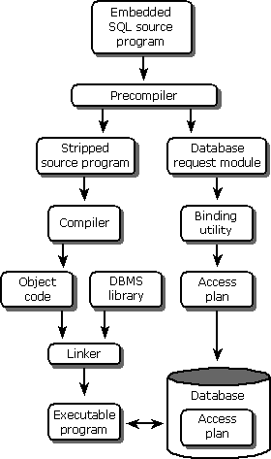

Five steps are involved in compiling an embedded SQL program:
- The embedded SQL program is submitted to the SQL precompiler, a programming tool. The precompiler scans the program, finds the embedded SQL statements, and processes them. A different precompiler is required for each programming language supported by the DBMS. DBMS products typically offer precompilers for one or more languages, including C, Pascal, COBOL, Fortran, Ada, PL/I, and various assembly languages.
- The precompiler produces two output files. The first file is the source file, stripped of its embedded SQL statements. In their place, the precompiler substitutes calls to proprietary DBMS routines that provide the run-time link between the program and the DBMS. Typically, the names and the calling sequences of these routines are known only to the precompile and the DBMS; they are not a public interface to the DBMS. The second file is a copy of all the embedded SQL statements used in the program. This file is sometimes called a database request module, or DBRM.
- The source file output from the precompile is submitted to the standard compiler for the host programming language (such as a C or COBOL compiler). The compiler processes the source code and produces object code as its output. Note that this step has nothing to do with the DBMS or with SQL.
- The linker accepts the object modules generated by the compiler, links them with various library routines, and produces an executable program. The library routines linked into the executable program include the proprietary DBMS routines described in step 2.
- The database request module generated by the precompile is submitted to a special binding utility. This utility examines the SQL statements, parses, validates, and optimizes them, and then produces an access plan for each statement. The result is a combined access plan for the entire program, representing an executable version of the embedded SQL statements. The binding utility stores the plan in the database, usually assigning it the name of the application program that will use it. Whether this step takes place at compile time or run time depends on the DBMS.

Triggers in PL/SQL
Triggers are stored programs, which are automatically executed or fired when some events occur. Triggers are, in fact, written to be executed in response to any of the following events −
- A database manipulation (DML) statement (DELETE, INSERT, or UPDATE)
- A database definition (DDL) statement (CREATE, ALTER, or DROP).
- A database operation (SERVERERROR, LOGON, LOGOFF, STARTUP, or SHUTDOWN).
Triggers can be defined on the table, view, schema, or database with which the event is associated.

Benefits of Triggers
Triggers can be written for the following purposes −
- Generating some derived column values automatically
- Enforcing referential integrity
- Event logging and storing information on table access
- Auditing
- Synchronous replication of tables
- Imposing security authorizations
- Preventing invalid transactions

Creating Triggers
The syntax for creating a trigger is −
CREATE [OR REPLACE ] TRIGGER trigger_name
{BEFORE | AFTER | INSTEAD OF }
{INSERT [OR] | UPDATE [OR] | DELETE}
[OF col_name]
ON table_name
[REFERENCING OLD AS o NEW AS n]
[FOR EACH ROW]
WHEN (condition)
DECLARE
Declaration-statements
BEGIN
Executable-statements
EXCEPTION
Exception-handling-statements
END;

Where,
- CREATE [OR REPLACE] TRIGGER trigger_name − Creates or replaces an existing trigger with the trigger_name.
- {BEFORE | AFTER | INSTEAD OF} − This specifies when the trigger will be executed. The INSTEAD OF clause is used for creating trigger on a view.
- {INSERT [OR] | UPDATE [OR] | DELETE} − This specifies the DML operation.
- [OF col_name] − This specifies the column name that will be updated.
- [ON table_name] − This specifies the name of the table associated with the trigger.
- [REFERENCING OLD AS o NEW AS n] − This allows you to refer new and old values for various DML statements, such as INSERT, UPDATE, and DELETE.
- [FOR EACH ROW] − This specifies a row-level trigger, i.e., the trigger will be executed for each row being affected. Otherwise the trigger will execute just once when the SQL statement is executed, which is called a table level trigger.
- WHEN (condition) − This provides a condition for rows for which the trigger would fire. This clause is valid only for row-level triggers.

Example
Select * from customers;

+----+----------+-----+-----------+----------+
| ID | NAME | AGE | ADDRESS | SALARY |
+----+----------+-----+-----------+----------+
| 1 | Ramesh | 32 | Ahmedabad | 2000.00 |
| 2 | Khilan | 25 | Delhi | 1500.00 |
| 3 | kaushik | 23 | Kota | 2000.00 |
| 4 | Chaitali | 25 | Mumbai | 6500.00 |
| 5 | Hardik | 27 | Bhopal | 8500.00 |
| 6 | Komal | 22 | MP | 4500.00 |
+----+----------+-----+-----------+----------+
The following program creates a row-level trigger for the customers table that would fire for INSERT or UPDATE or DELETE operations performed on the CUSTOMERS table. This trigger will display the salary difference between the old values and new values −
CREATE OR REPLACE TRIGGER display_salary_changes
BEFORE DELETE OR INSERT OR UPDATE ON customers
FOR EACH ROW
WHEN (NEW.ID > 0)
DECLARE
sal_diff number;
BEGIN
sal_diff := :NEW.salary - :OLD.salary;
dbms_output.put_line('Old salary: ' || :OLD.salary);
dbms_output.put_line('New salary: ' || :NEW.salary);
dbms_output.put_line('Salary difference: ' || sal_diff);
END;

Triggering a Trigger
Let us perform some DML operations on the CUSTOMERS table. Here is one INSERT statement, which will create a new record in the table −
INSERT INTO CUSTOMERS (ID,NAME,AGE,ADDRESS,SALARY)
VALUES (7, 'Kriti', 22, 'HP', 7500.00 );
When a record is created in the CUSTOMERS table, the above create trigger, display_salary_changes will be fired and it will display the following result −
Old salary:
New salary: 7500
Salary difference:
Because this is a new record, old salary is not available and the above result comes as null. Let us now perform one more DML operation on the CUSTOMERS table. The UPDATE statement will update an existing record in the table −
UPDATE customers
SET salary = salary + 500
WHERE id = 2;
When a record is updated in the CUSTOMERS table, the above create trigger, display_salary_changes will be fired and it will display the following result −
Old salary: 1500
New salary: 2000
Salary difference: 500

Cursors in PL/SQL
Oracle creates a memory area, known as the context area, for processing an SQL statement, which contains all the information needed for processing the statement; for example, the number of rows processed, etc.
A cursor is a pointer to this context area. PL/SQL controls the context area through a cursor. A cursor holds the rows (one or more) returned by a SQL statement. The set of rows the cursor holds is referred to as the active set.
You can name a cursor so that it could be referred to in a program to fetch and process the rows returned by the SQL statement, one at a time. There are two types of cursors −
- Implicit cursors
- Explicit cursors

Implicit Cursors
Implicit cursors are automatically created by Oracle whenever an SQL statement is executed, when there is no explicit cursor for the statement. Programmers cannot control the implicit cursors and the information in it.
Whenever a DML statement (INSERT, UPDATE and DELETE) is issued, an implicit cursor is associated with this statement. For INSERT operations, the cursor holds the data that needs to be inserted. For UPDATE and DELETE operations, the cursor identifies the rows that would be affected.
In PL/SQL, you can refer to the most recent implicit cursor as the SQL cursor, which always has attributes such as %FOUND, %ISOPEN, %NOTFOUND, and %ROWCOUNT. The SQL cursor has additional attributes, %BULK_ROWCOUNT and %BULK_EXCEPTIONS, designed for use with the FORALL statement. The following table provides the description of the most used attributes −
S.No | Attribute & Description
1 | %FOUND  Returns TRUE if an INSERT, UPDATE, or DELETE statement affected one or more rows or a SELECT INTO statement returned one or more rows. Otherwise, it returns FALSE.
2 | %NOTFOUND  The logical opposite of %FOUND. It returns TRUE if an INSERT, UPDATE, or DELETE statement affected no rows, or a SELECT INTO statement returned no rows. Otherwise, it returns FALSE.
3 | %ISOPEN  Always returns FALSE for implicit cursors, because Oracle closes the SQL cursor automatically after executing its associated SQL statement.
4 | %ROWCOUNT  Returns the number of rows affected by an INSERT, UPDATE, or DELETE statement, or returned by a SELECT INTO statement.
Any SQL cursor attribute will be accessed as sql%attribute_name as shown below in the example.

Example
We will be using the CUSTOMERS table we had created
Select * from customers;

+----+----------+-----+-----------+----------+
| ID | NAME | AGE | ADDRESS | SALARY |
+----+----------+-----+-----------+----------+
| 1 | Ramesh | 32 | Ahmedabad | 2000.00 |
| 2 | Khilan | 25 | Delhi | 1500.00 |
| 3 | kaushik | 23 | Kota | 2000.00 |
| 4 | Chaitali | 25 | Mumbai | 6500.00 |
| 5 | Hardik | 27 | Bhopal | 8500.00 |
| 6 | Komal | 22 | MP | 4500.00 |
+----+----------+-----+-----------+----------+
The following program will update the table and increase the salary of each customer by 500 and use the SQL%ROWCOUNT attribute to determine the number of rows affected −
DECLARE
total_rows number(2);
BEGIN
UPDATE customers
SET salary = salary + 500;
IF sql%notfound THEN
dbms_output.put_line('no customers selected');
ELSIF sql%found THEN
total_rows := sql%rowcount;
dbms_output.put_line( total_rows || ' customers selected ');
END IF;
END;
/

If you check the records in customers table, you will find that the rows have been updated
Select * from customers;

+----+----------+-----+-----------+----------+
| ID | NAME | AGE | ADDRESS | SALARY |
+----+----------+-----+-----------+----------+
| 1 | Ramesh | 32 | Ahmedabad | 2500.00 |
| 2 | Khilan | 25 | Delhi | 2000.00 |
| 3 | kaushik | 23 | Kota | 2500.00 |
| 4 | Chaitali | 25 | Mumbai | 7000.00 |
| 5 | Hardik | 27 | Bhopal | 9000.00 |
| 6 | Komal | 22 | MP | 5000.00 |
+----+----------+-----+-----------+----------+

Explicit Cursors
Explicit cursors are programmer-defined cursors for gaining more control over the context area. An explicit cursor should be defined in the declaration section of the PL/SQL Block. It is created on a SELECT Statement which returns more than one row.
The syntax for creating an explicit cursor is −
CURSOR cursor_name IS select_statement;
Working with an explicit cursor includes the following steps −
- Declaring the cursor for initializing the memory
- Opening the cursor for allocating the memory
- Fetching the cursor for retrieving the data
- Closing the cursor to release the allocated memory

Declaring the Cursor
Declaring the cursor defines the cursor with a name and the associated SELECT statement. For example −
CURSOR c_customers IS
SELECT id, name, address FROM customers;

Opening the Cursor
Opening the cursor allocates the memory for the cursor and makes it ready for fetching the rows returned by the SQL statement into it. For example, we will open the above defined cursor as follows −
OPEN c_customers;

Fetching the Cursor
Fetching the cursor involves accessing one row at a time. For example, we will fetch rows from the above-opened cursor as follows −

FETCH c_customers INTO c_id, c_name, c_addr;

Closing the Cursor
Closing the cursor means releasing the allocated memory. For example, we will close the above-opened cursor as follows −
CLOSE c_customers;

Example
Following is a complete example to illustrate the concepts of explicit cursors &minua;
DECLARE
c_id customers.id%type;
c_name customerS.No.ame%type;
c_addr customers.address%type;
CURSOR c_customers is
SELECT id, name, address FROM customers;
BEGIN
OPEN c_customers;
LOOP
FETCH c_customers into c_id, c_name, c_addr;
EXIT WHEN c_customers%notfound;
dbms_output.put_line(c_id || ' ' || c_name || ' ' || c_addr);
END LOOP;
CLOSE c_customers;
END;
/
When the above code is executed at the SQL prompt, it produces the following result −
1 Ramesh Ahmedabad
2 Khilan Delhi
3 kaushik Kota
4 Chaitali Mumbai
5 Hardik Bhopal
6 Komal MP

Procedures in PL/SQL
A subprogram is a program unit/module that performs a particular task. These subprograms are combined to form larger programs. This is basically called the 'Modular design'. A subprogram can be invoked by another subprogram or program which is called the calling program.
A subprogram can be created −
- At the schema level
- Inside a package
- Inside a PL/SQL block
At the schema level, subprogram is a standalone subprogram. It is created with the CREATE PROCEDURE or the CREATE FUNCTION statement. It is stored in the database and can be deleted with the DROP PROCEDURE or DROP FUNCTION statement.
A subprogram created inside a package is a packaged subprogram. It is stored in the database and can be deleted only when the package is deleted with the DROP PACKAGE statement. We will discuss packages in the chapter 'PL/SQL - Packages'.
PL/SQL subprograms are named PL/SQL blocks that can be invoked with a set of parameters. PL/SQL provides two kinds of subprograms −
- Functions − These subprograms return a single value; mainly used to compute and return a value.
- Procedures − These subprograms do not return a value directly; mainly used to perform an action.
This chapter is going to cover important aspects of a PL/SQL procedure. We will discuss PL/SQL function in the next chapter.

Parts of a PL/SQL Subprogram
Each PL/SQL subprogram has a name, and may also have a parameter list. Like anonymous PL/SQL blocks, the named blocks will also have the following three parts −
S.No | Parts & Description
1 | Declarative Part  It is an optional part. However, the declarative part for a subprogram does not start with the DECLARE keyword. It contains declarations of types, cursors, constants, variables, exceptions, and nested subprograms. These items are local to the subprogram and cease to exist when the subprogram completes execution.
2 | Executable Part  This is a mandatory part and contains statements that perform the designated action.
3 | Exception-handling  This is again an optional part. It contains the code that handles run-time errors.

Creating a Procedure
A procedure is created with the CREATE OR REPLACE PROCEDURE statement. The simplified syntax for the CREATE OR REPLACE PROCEDURE statement is as follows −
CREATE [OR REPLACE] PROCEDURE procedure_name
[(parameter_name [IN | OUT | IN OUT] type [, ...])]
{IS | AS}
BEGIN
< procedure_body >
END procedure_name;
Where,
- procedure-name specifies the name of the procedure.
- [OR REPLACE] option allows the modification of an existing procedure.
- The optional parameter list contains name, mode and types of the parameters. IN represents the value that will be passed from outside and OUT represents the parameter that will be used to return a value outside of the procedure.
- procedure-body contains the executable part.
- The AS keyword is used instead of the IS keyword for creating a standalone procedure.

Example
The following example creates a simple procedure that displays the string 'Hello World!' on the screen when executed.
CREATE OR REPLACE PROCEDURE greetings
AS
BEGIN
dbms_output.put_line('Hello World!');
END;
/
.

Executing a Standalone Procedure
A standalone procedure can be called in two ways −
- Using the EXECUTE keyword
- Calling the name of the procedure from a PL/SQL block
The above procedure named 'greetings' can be called with the EXECUTE keyword as −
EXECUTE greetings;

The procedure can also be called from another PL/SQL block −
BEGIN
greetings;
END;
/
The above call will display −
Hello World

PL/SQL procedure successfully completed.

Deleting a Standalone Procedure
A standalone procedure is deleted with the DROP PROCEDURE statement. Syntax for deleting a procedure is −
DROP PROCEDURE procedure-name;
You can drop the greetings procedure by using the following statement −
DROP PROCEDURE greetings;

Parameter Modes in PL/SQL Subprograms
The following table lists out the parameter modes in PL/SQL subprograms −
S.No | Parameter Mode & Description
1 | IN  An IN parameter lets you pass a value to the subprogram. It is a read-only parameter. Inside the subprogram, an IN parameter acts like a constant. It cannot be assigned a value. You can pass a constant, literal, initialized variable, or expression as an IN parameter. You can also initialize it to a default value; however, in that case, it is omitted from the subprogram call. It is the default mode of parameter passing. Parameters are passed by reference.
2 | OUT  An OUT parameter returns a value to the calling program. Inside the subprogram, an OUT parameter acts like a variable. You can change its value and reference the value after assigning it. The actual parameter must be variable and it is passed by value.
3 | IN OUT  An IN OUT parameter passes an initial value to a subprogram and returns an updated value to the caller. It can be assigned a value and the value can be read.  The actual parameter corresponding to an IN OUT formal parameter must be a variable, not a constant or an expression. Formal parameter must be assigned a value. Actual parameter is passed by value.

IN & OUT Mode Example 1
This program finds the minimum of two values. Here, the procedure takes two numbers using the IN mode and returns their minimum using the OUT parameters.
DECLARE
a number;
b number;
c number;
PROCEDURE findMin(x IN number, y IN number, z OUT number) IS
BEGIN
IF x < y THEN
z:= x;
ELSE
z:= y;
END IF;
END;
BEGIN
a:= 23;
b:= 45;
findMin(a, b, c);
dbms_output.put_line(' Minimum of (23, 45) : ' || c);
END;
/
When the above code is executed at the SQL prompt, it produces the following result −
Minimum of (23, 45) : 23

PL/SQL procedure successfully completed.

IN & OUT Mode Example 2
This procedure computes the square of value of a passed value. This example shows how we can use the same parameter to accept a value and then return another result.

DECLARE
a number;
PROCEDURE squareNum(x IN OUT number) IS
BEGIN
x := x * x;
END;
BEGIN
a:= 23;
squareNum(a);
dbms_output.put_line(' Square of (23): ' || a);
END;
/
When the above code is executed at the SQL prompt, it produces the following result −
Square of (23): 529

PL/SQL procedure successfully completed.

Methods for Passing Parameters
Actual parameters can be passed in three ways −
- Positional notation
- Named notation
- Mixed notation

Positional Notation
In positional notation, you can call the procedure as −
findMin(a, b, c, d);
In positional notation, the first actual parameter is substituted for the first formal parameter; the second actual parameter is substituted for the second formal parameter, and so on. So, a is substituted for x, b is substituted for y, c is substituted for z and d is substituted for m.

Named Notation
In named notation, the actual parameter is associated with the formal parameter using the arrow symbol ( => ). The procedure call will be like the following −
findMin(x => a, y => b, z => c, m => d);

Mixed Notation
In mixed notation, you can mix both notations in procedure call; however, the positional notation should precede the named notation.
The following call is legal −
findMin(a, b, c, m => d);
However, this is not legal:
findMin(x => a, b, c, d);

Functions in PL/SQL
A function is same as a procedure except that it returns a value. Therefore, all the discussions of the previous chapter are true for functions too.

Creating a Function
A standalone function is created using the CREATE FUNCTION statement. The simplified syntax for the CREATE OR REPLACE PROCEDURE statement is as follows −
CREATE [OR REPLACE] FUNCTION function_name
[(parameter_name [IN | OUT | IN OUT] type [, ...])]
RETURN return_datatype
{IS | AS}
BEGIN
< function_body >
END [function_name];
Where,
- function-name specifies the name of the function.
- [OR REPLACE] option allows the modification of an existing function.
- The optional parameter list contains name, mode and types of the parameters. IN represents the value that will be passed from outside and OUT represents the parameter that will be used to return a value outside of the procedure.
- The function must contain a return statement.
- The RETURN clause specifies the data type you are going to return from the function.
- function-body contains the executable part.
- The AS keyword is used instead of the IS keyword for creating a standalone function.

Example
The following example illustrates how to create and call a standalone function. This function returns the total number of CUSTOMERS in the customers table.
We will use the CUSTOMERS table.
Select * from customers;

+----+----------+-----+-----------+----------+
| ID | NAME | AGE | ADDRESS | SALARY |
+----+----------+-----+-----------+----------+
| 1 | Ramesh | 32 | Ahmedabad | 2000.00 |
| 2 | Khilan | 25 | Delhi | 1500.00 |
| 3 | kaushik | 23 | Kota | 2000.00 |
| 4 | Chaitali | 25 | Mumbai | 6500.00 |
| 5 | Hardik | 27 | Bhopal | 8500.00 |
| 6 | Komal | 22 | MP | 4500.00 |
+----+----------+-----+-----------+----------+

CREATE OR REPLACE FUNCTION totalCustomers
RETURN number IS
total number(2) := 0;
BEGIN
SELECT count(*) into total
FROM customers;

RETURN total;
END;
/

Calling a Function
While creating a function, you give a definition of what the function has to do. To use a function, you will have to call that function to perform the defined task. When a program calls a function, the program control is transferred to the called function.
A called function performs the defined task and when its return statement is executed or when the last end statement is reached, it returns the program control back to the main program.
To call a function, you simply need to pass the required parameters along with the function name and if the function returns a value, then you can store the returned value. Following program calls the function totalCustomers from an anonymous block −
DECLARE
c number(2);
BEGIN
c := totalCustomers();
dbms_output.put_line('Total no. of Customers: ' || c);
END;
/
When the above code is executed at the SQL prompt, it produces the following result −
Total no. of Customers: 6

PL/SQL procedure successfully completed.

Example
The following example demonstrates Declaring, Defining, and Invoking a Simple PL/SQL Function that computes and returns the maximum of two values.
DECLARE
a number;
b number;
c number;
FUNCTION findMax(x IN number, y IN number)
RETURN number
IS
z number;
BEGIN
IF x > y THEN
z:= x;
ELSE
Z:= y;
END IF;
RETURN z;
END;
BEGIN
a:= 23;
b:= 45;
c := findMax(a, b);
dbms_output.put_line(' Maximum of (23,45): ' || c);
END;
/
When the above code is executed at the SQL prompt, it produces the following result −
Maximum of (23,45): 45

PL/SQL procedure successfully completed.

PL/SQL Recursive Functions
We have seen that a program or subprogram may call another subprogram. When a subprogram calls itself, it is referred to as a recursive call and the process is known as recursion.
To illustrate the concept, let us calculate the factorial of a number. Factorial of a number n is defined as −
n! = n*(n-1)!
= n*(n-1)*(n-2)!
...
= n*(n-1)*(n-2)*(n-3)... 1
The following program calculates the factorial of a given number by calling itself recursively −
DECLARE
num number;
factorial number;

FUNCTION fact(x number)
RETURN number
IS
f number;
BEGIN
IF x=0 THEN
f := 1;
ELSE
f := x * fact(x-1);
END IF;
RETURN f;
END;

BEGIN
num:= 6;
factorial := fact(num);
dbms_output.put_line(' Factorial '|| num || ' is ' || factorial);
END;
/
When the above code is executed at the SQL prompt, it produces the following result −
Factorial 6 is 720

PL/SQL procedure successfully completed.

Query Processing

Steps in query processing

1. Parsing and translation
2. Optimization
3. Evaluation

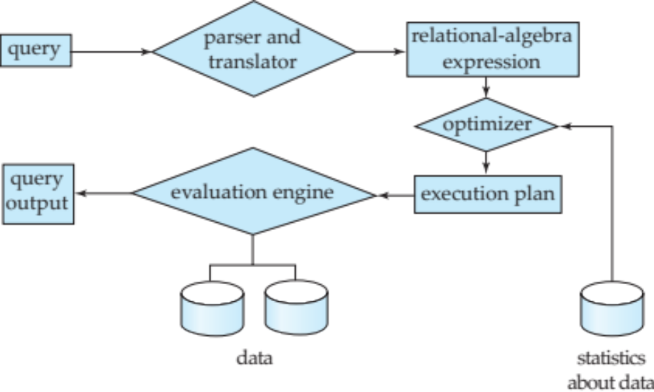

- Parsing and translation
  - translate the query into its internal form. This is then translated into relational algebra.
  - Parser checks syntax, verifies relations
- Evaluation
  - The query-execution engine takes a query-evaluation plan, executes that plan, and returns the answers to the query.

Steps in query processing

- A relational algebra expression may have many equivalent expressions
  - E.g., σ_{salary<75000}(∏_{salary}(instructor)) is equivalent to
∏_{salary}(σ_{salary<75000}(instructor))
- Each relational algebra operation can be evaluated using one of several different algorithms
  - Correspondingly, a relational-algebra expression can be evaluated in many ways.
- Annotated expression specifying detailed evaluation strategy is called an evaluation-plan.
  - E.g., can use an index on salary to find instructors with salary < 75000,
  - or can perform complete relation scan and discard instructors with salary ≥ 75000
- Query Optimization: Amongst all equivalent evaluation plans choose the one with lowest cost.
  - Cost is estimated using statistical information from the
database catalog
e.g. number of tuples in each relation, size of tuples, etc

Measures of Query cost

- Cost is generally measured as total elapsed time for answering query
  - Many factors contribute to time cost
    - disk accesses, CPU, or even network communication
- Typically disk access is the predominant cost, and is also relatively easy to estimate. Measured by taking into account
  - Number of seeks * average-seek-cost
  - Number of blocks read * average-block-read-cost
  - Number of blocks written * average-block-write-cost
    - Cost to write a block is greater than cost to read a block
      - data is read back after being written to ensure that the write was successful

- For simplicity we just use the number of block transfers from disk and the number of seeks as the cost measures
t_{T} – time to transfer one block
t_{S} – time for one seek
- Cost for b block transfers plus S seeks
b * t_{T} + S * t_{S}
- We ignore CPU costs for simplicity
- Real systems do take CPU cost into account
- We do not include cost to writing output to disk in our cost formulae
- Several algorithms can reduce disk IO by using extra buffer space
- Amount of real memory available to buffer depends on other concurrent queries and OS processes, known only during execution
- We often use worst case estimates, assuming only the minimum amount of memory needed for the operation is available
- Required data may be buffer resident already, avoiding disk I/O
But hard to take into account for cost estimation

SELECT OPERATION

- File scan
  - Algorithm A1 (linear search). Scan each file block and test all records to see whether they satisfy the selection condition.
  - Cost estimate = b_{r} block transfers + 1 seek
  - b_{r} denotes number of blocks containing records from relation r
- If selection is on a key attribute, can stop on finding record
  - cost = (b_{r} /2) block transfers + 1 seek
- Linear search can be applied regardless of selection condition or ordering of records in the file, or availability of indices

Note: binary search generally does not make sense since data is not stored consecutively except when there is an index available, and binary search requires more seeks than index search

SELECTION USING INDICES

- Index scan – search algorithms that use an index
  - selection condition must be on search-key of index.
- A2 (primary index, equality on key). Retrieve a single record that satisfies the corresponding equality condition
  - Cost = (h_{i} + 1) * (t_{T} + t_{S})
- A3 (primary index, equality on nonkey) Retrieve multiple records.
  - Records will be on consecutive blocks
    - Let b = number of blocks containing matching records
  - Cost = h_{i} * (t_{T} + t_{S}) + t_{S} + t_{T} * b
- A4 (secondary index, equality on nonkey).
  - Retrieve a single record if the search-key is a candidate key
    - Cost = (h_{i} + 1) * (t_{T} + t_{S})
  - Retrieve multiple records if search-key is not a candidate key
    - each of n matching records may be on a different block
    - Cost = (h_{i} + n) * (t_{T} + t_{S})
      - Can be very expensive!
- Can implement selections of the form σ_{A≤V} (r) or σ_{A ≥ V}(r) by using
  - a linear file scan,
  - or by using indices in the following ways:
- A5 (primary index, comparison). (Relation is sorted on A)
    - For σ_{A ≥ V}(r) use index to find first tuple ≥ v and scan relation sequentially from there
    - For σ_{A≤V} (r) just scan relation sequentially till first tuple > v; do not use index
- A6 (secondary index, comparison).
    - For σ_{A ≥ V}(r) use index to find first index entry ≥ v and scan index sequentially from there, to find pointers to records.
    - For σ_{A≤V} (r) just scan leaf pages of index finding pointers to records, till first entry > v
    - In either case, retrieve records that are pointed to
      - requires an I/O for each record
      - Linear file scan may be cheaper

List of Experiments:

As this subject is following the project based teaching learning methodology, consider the project ABC using SQL based software mySQL. Each student is required to prepare the report for the following experiments.

Experiment 1
TITLE: DDL (Data Definition Language) commands
Objective: To understand the concept of designing issue related to the database with creating, populating the tables.
- Create the tables described below:
Table name: CLIENT_MASTER Description: used to store client information.
Column name | data type | Size
CLIENTNO | Varchar | 6
NAME | Varchar | 20
ADDRESS 1 | Varchar | 30
ADDRESS 2 | Varchar | 30
CITY | Varchar | 15
PINCODE | Integer
STATE | Varchar | 15
BALDUE | decimal | 10,2

Table Name: PRODUCT_MASTER Description: used to store product information
Column name | data type | Size
PRODUCTNO | Varchar | 6
DESCRIPTION | Varchar | 15
PROFITPERCENT | Decimal | 4,2
UNIT MEASURE | Varchar | 10
QTYONHAND | Integer
REORDERL VL | Integer
SELLPRICE | Decimal | 8,2
COSTPRICE | Decimal | 8,2
Table Name: SALESMAN_MASTER
Description: Used to store salesman information working for the company.
Column name | data type | Size
SALESMANNO | Varchar | 6
SALESMANNAME | Varchar | 20
ADDRESS 1 | Varchar | 30
ADDRESS 2 | Varchar | 30
CITY | Varchar | 20
PINCODE | Integer
STATE | Varchar | 20
SALAMT | Real
TGTTOGET | Decimal
YTDSALES | Double | 6,2
REMARKS | Varchar | 60

- Insert the following data into their respective tables:
- Data for CLIENT_MASTER table:
Client no | Name | city | Pincode | state | BalDue
C00001 | Ivan bayross | Mumbai | 400054 | Maharashtra | 15000
C00002 | Mamta muzumdar | Madras | 780001 | Tamil nadu | 0
C00003 | Chhaya bankar | Mumbai | 400057 | Maharashtra | 5000
C00004 | Ashwini joshi | Bangalore | 560001 | Karnataka | 0
C00005 | Hansel colaco | Mumbai | 400060 | Maharashtra | 2000
C00006 | Deepak sharma | Mangalore | 560050 | Karnataka | 0

- Data for PRODUCT_MASTER table:
ProductNo | Description | Profit percent | Unit measure | Qtyonhand | RecorderLvl | SellPrice | CostPrice
P00001 | T-Shirt | 5 | Piece | 200 | 50 | 350 | 250
P0345 | Shirts | 6 | Piece | 150 | 50 | 500 | 350
P06734 | Cotton jeans | 5 | Piece | 100 | 20 | 600 | 450
P07865 | Jeans | 5 | Piece | 100 | 20 | 750 | 500
P07868 | Trousers | 2 | Piece | 150 | 50 | 850 | 550
P07885 | Pull Overs | 2.5 | Piece | 80 | 30 | 700 | 450
P07965 | Denim jeans | 4 | Piece | 100 | 40 | 350 | 250
P07975 | Lycra tops | 5 | Piece | 70 | 30 | 300 | 175
P08865 | Skirts | 5 | Piece | 75 | 30 | 450 | 300

- Data for SALESMAN_MASTER table:

SalesmanNo | Name | Address1 | Address2 | City | PinCode | State
S00001 | Aman | A/14 | Worli | Mumbai | 400002 | Maharashtra
S00002 | Omkar | 65 | Nariman | Mumbai | 400001 | Maharashtra
S00003 | Raj | P-7 | Bandra | Mumbai | 400032 | Maharashtra
S00004 | Ashish | A/5 | Juhu | Mumbai | 400044 | Maharashtra

SalesmanNo | SalAmt | TgtToGet |  | YtdSales |  | Remarks
S00001 | 3000 | 100 | 50 |  | Good
S00002 | 3000 | 200 | 100 |  | Good
S00003 | 3000 | 200 | 100 |  | Good
S00004 | 3500 | 200 | 150 |  | Good

***************************************************************************
Experiment 2
Title: DML commands with constraints
Objective: - To understand the concept of different DML commands.
- Exercise on retrieving records from a table.
a. Find out the names of all the clients.
b. Retrieve the entire contents of the Client_Master table.
c. Retrieve the list of names,city and the state of all the clients.
d. List the various products available from the Product_Master table.
e. List all the clients who are located in Mumbai.
f. Find the names of salesman who have a salary equal to Rs.3000.
- Exercise on updating records in a table
a. Change the city of ClientNo ‘C00005’ to ‘Bangalore’.
b. Change the BalDue of ClientNo ‘C00001’ to Rs.1000.
c. Change the cost price of ‘Trousers’ to rs.950.00.
d. Change the city of the salesman to Pune.
- Exercise on deleting records in a table
a. Delete all salesman from the Salesman_Master whose salaries are equal to Rs.3500.
b. Delete all products from Product_Master where the quantity on hand is equal to 100.
c. Delete from Client_Master where the column state holds the value ‘Tamil Nadu’.
- Exercise on altering the table structure
a. Add a column called ‘Telephone’ of data type integer to the Client_Master table.
b. Change the size off SellPrice column in Product _Master to 10, 2.
- Exercise on deleting the table structure along with the data
a. Destroy the table Client_Master along with its data.
- Exercise on renaming the table
a. Change the name of the Salesman_Master to sman_mast.
***************************************************************

EXPERIMENT-3
TITLE: DDL (Data Definition Language) commands with Data Constraints
Objective: To understand the concept of data constraints that is enforced on data being stored in the table. Focus on Primary Key and the Foreign Key
Create the tables described below:
Table name: CLIENT_MASTER_1 Description: used to store client information.
Column name | data type | Size | Constraints
CLIENTNO | Varchar | 6 | Primary key / first letter must start with ‘C’
NAME | Varchar | 20 | Not Null
ADDRESS 1 | Varchar | 30
ADDRESS 2 | Varchar | 30
CITY | Varchar | 15
PINCODE | Integer | 8
STATE | Varchar | 15
BALDUE | Decimal | 10,2

Table Name: PRODUCT_MASTER_1 Description: used to store product information
Column name | data type | Size | Attributes
PRODUCTNO | Varchar | 6 | Primary Key/ first letter must start with ‘P’
DESCRIPTION | Varchar | 15 | Not Null
PROFITPERCENT | Decimal | 4,2 | Not Null
UNIT MEASURE | Varchar | 10 | Not Null
QTYONHAND | Integer | 8 | Not Null
REORDERL VL | Integer | 8 | Not Null
SELLPRICE | Decimal | 8,2 | Not Null
COSTPRICE | Decimal | 8,2 | Not Null

Table Name: SALESMAN_MASTER _1
Description: used to store salesman information working for the company.
Column name | data type | Size | Attributes
SALESMANNO | Varchar | 6 | Primary Key/ first letter must start with ‘S’
SALESMANNAME | Varchar | 20 | Not Null
ADDRESS 1 | Varchar | 30 | Not Null
ADDRESS 2 | Varchar | 30
CITY | Varchar | 20
PINCODE | Integer | 8
STATE | Varchar | 20
SALAMT | Real | 8,2 | Not Null , Cannot be 0
TGTTOGET | Decimal | 6,2 | Not Null , Cannot be 0
YTDSALES | Double | 6,2 | Not Null
REMARKS | Varchar | 60

- Reinsert the data in these two tables based upon Lab 2.
- Display the contents of each table.
***************************************************************************
EXPERIMENT-4
TITLE: DDL (Data Definition Language) commands with Data Constraints
Objective: To understand the concept of data constraints that is enforced on data being stored in the table. Focus on Primary Key, The Foreign Key and constraints.
Review this diagram
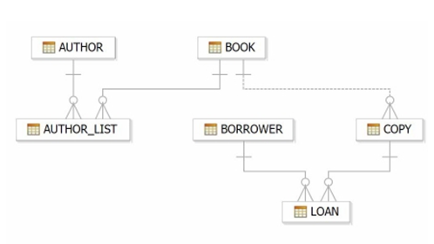
- Create table AUTHOR = {Author_ID , Lastname, Firstname, Email, City, Country}
Where:
Author_ID – text data type, 5 characters, primary key
Lastname – text data type, 15 characters, not null
Firstname – text data type, 15 characters, not null
Email – text data type, 40 characters,
City – text data type, 15 characters,
Country – text data type, 15 characters,
- Create Table BOOK={ Book_ID, Book_Title, Copies)
Where :
Book_ID – text data type, 5 characters Primary Key Start With Character B
Book_Title - Text data Type Not Null
Copies- No.of copies Data Type int always greater the 2
- Create table AUTHOR_LIST = {Author_ID , Book_ID , Role}
Where:
Author_ID – text data type, 5 characters, referenced by Author_ID from AUTHOR
table
Book_ID – text data type, 5 characters
Role – text data type, 15 characters
and primary key is: Author_ID, Book_ID
- Add four records in each tables AUTHOR, BOOK, BOOK_LIST.
- Alter structure of table AUTHOR_LIST add the field Publisher data type of 30 Character.
***************************************************************
EXPERIMENT- 5,6
Title: Use of Inbuilt functions and relational algebra operation
Objective: To understand the use of inbuilt function and relational algebra with sql query.
1. Consider the following table structure and attempt.
Supplier-(scode,sname,scity,turnover)
Part-(pcode,weigh,color,cost,sellingprice)
Supplier_Part-(scode,pcode,qty)
a) Create tables
b) Populate the table.
2. Write appropriate SQL Statement for the following:
1. Get the supplier number and part number in ascending order of supplier number.
2. Get the details of supplier who operate from Bombay with turnover 50.
3. Get the total number of supplier.
4. Get the part number weighing between 25 and 35.
5. Get the supplier number whose turnover is null.
6. Get the part number that cost 20, 30 or 40 rupees.
7. Get the total quantity of part 2 that is supplied.
8. Get the name of supplier who supply part 2.
9. Get the part number whose cost is greater than the average cost.
10. Get the supplier number and turnover in descending order of turnover.

EXPERIMENT-7,8
TITLE: Nested sql queries or Subquries
Objective: To understand the use SQL Subquery
1.Create the following two tables (EMP and DEPT)
EMP TABLE
EMPNO ENAME JOB MGR HIREDATE SAL COMM DEPTNO
---------- ---------- --------- ---------- --------- ---------- ---------- ----------
7369 SMITH CLERK 7902 17-DEC-80 500 800 20
7499 ALLEN SALESMAN 7698 20-FEB-81 1600 300 30
7521 WARD SALESMAN 7698 22-FEB-81 1250 500 30
7566 JONES MANAGER 7839 02-APR-81 2975 20
7654 MARTIN SALESMAN 7698 28-SEP-81 1250 1400 30
7698 BLAKE MANAGER 7839 01-MAY-81 2850 30
7782 CLARK MANAGER 7839 09-JUN-81 2450 10
7788 SCOTT ANALYST 7566 09-DEC-82 3000 20
7839 KING PRESIDENT 17-NOV-81 5000 10
7844 TURNER SALESMAN 7698 08-SEP-81 1500 0 30
7876 ADAMS CLERK 7788 12-JAN-83 1100 20
7900 JAMES CLERK 7698 03-DEC-81 950 30
7902 FORD ANALYST 7566 03-DEC-81 3000 20
7934 MILLER CLERK 7782 23-JAN-82 1300 10

DEPT TABLE
DEPTNO DNAME LOC
---------- -------------- -------------
10 ACCOUNTING NEW YORK
20 RESEARCH DALLAS
30 SALES CHICAGO
40 OPERATIONS BOSTON

Write the Nested Queries for the following queries.
- List the details of the emps whose Salaries more than the employee BLAKE.
- List the emps whose Jobs are same as ALLEN.
- List the Emps whose Sal is same as FORD or SMITH in desc order of Names.
- List the emps Whose Jobs are same as MILLER or Sal is more than ALLEN.
- Find the highest paid employee of sales department.
- List the employees who are senior to most recently hired employee working under king.
List the employees who are senior to most recently hired employee working
under king.
select * from emp where hiredate < (select max(hiredate) from emp where mgr in (select empno from emp where ename = 'KING')) ;
- List the names of the emps who are getting the highest sal dept wise.
select e.ename,e.deptno from emp e where e.sal in
(select max(sal) from emp group by deptno) ;
- List the emps whose sal is equal to the average of max and minimum
select * from emp where sal =(select (max(sal)+min(sal))/2 from emp);
- List the emps who joined in the company on the same date.
select * from emp e where hiredate in (select hiredate from emp where e.empno <> empno);
- Find out the emps who joined in the company before their Managers.
select * from emp e where hiredate < (select hiredate from emp where
empno = e.mgr)
****************************************************************
EXPERIMENT-9
TITLE: Group by & having clause
Objective: To understand the use of group by and having clause.
Write the SQL Queries for the following queries (use EMP and DEPT table of Exp 8).
- List the Deptno where there are no emps.
- List the No.of emp’s and Avg salary within each department for each job.
- Find the maximum average salary drawn for each job except for ‘President’.
- List the department details where at least two emps are working.
- List the no. of emps in each department where the no. is more than 3.
- List the names of the emps who are getting the highest sal dept wise.
- List the Deptno and their average salaries for dept with the average salary less than the averages for all departments.
****************************************************************

EXPERIMENT-10
TITLE: Joins in SQL
AIM: To execute and verify the SQL commands using Join.
OBJECTIVE: SQL joins are used to query data from two or more tables, based on a relationship between certain columns in these tables.
Refer Experiment 7 & 8 and execute the same questions by using join.

